

Instruction for Use
Dot Pad 320
(DPA320X)

Table of Contents

Product Description / Intended Use 2
Symbol Definitions 3
Warnings and Precautions 5
Caution Information 5
Warning 6
1. About the Dot Pad 320 (DPA320X)+ 7
1.1. Dot Pad 320 7
1.1.1. Components of the Dot Pad 320 8
1.2. Dot Pad 320 Appearance 8
1.2.1 Dot Pad 320 Top View 9
1.2.2. Dot Pad 320 Right Side 9
1.2.3. Dot Pad 320 Left Side 10
1.2.4. Dot Pad 320 Bottom Surface 10
1.3. Specifications 10
2. Basic Functions 14
2.1. Understanding Dot Pad 320 LED Signals 14
2.2. Understanding Device Information through the Dot Pad 320’s Vibration Signals 14
2.3. Checking the Battery Level 15
3. Usage of Dot Pad 320 with VoiceOver 15
3.1 Connecting/Disconnecting with an iPhone/iPad 15
3.1.1. Connecting an iPhone/iPad With the Dot Pad 320 15
3.1.2. Disconnecting the Dot Pad 320 from an iPhone/iPad 15
3.2. Default Key Settings 16
3.3. Connecting iPhone/iPad With the Dot Pad 320 to Read Braille and Tactile Images 16
3.3.1. Reading Braille Text 16
3.3.2. Displaying the Image 16
3.4. Reading Images in Detail with Rotors 16
3.4.1. Adding Image Navigation Options to the Rotor 16
3.4.2. Using Image Inversion 17
3.4.3. Enlarging an Image 17
3.4.4. Scrolling Images Horizontally and Vertically 17
3.4.5. Adjusting the Image Line Thickness 17
3.5. Viewing Images Using Voiceover Recognition 17
3.5.1. Creating Image Recognition Gestures 18
3.5.2. Using the Image Recognition Function to View an Image 18
3.6. Customizing the Dot Pad 320 Keys 18
4. Optional Software & Screen Reader Integration 19
4.1 Introduction to Dot Canvas (App) 19
4.2 Introducing Dot Canvas (Web) 19
4.3 Integration with NVDA (Windows)…………………………………………………………..……. 19
4.4 Integration with JAWS (Windows)………………………………………………………………. ...19
4.5 Integration with VoiceOver (Apple OS)…………………………………………………………………19
5. Customer Support 19
5.1 Warranty 19
5.2. Product Lifetime 19
5.3. Notice to the user 19
6. Product Certifications 20

Instruction for Use for this product are also available in electronic form (eIFU). Access the eIFUs online at https://www.dotincorp.com/en/resources?category=etc | 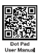

Product Description / Intended Use

Intended Purpose
The Dot Pad 320 is a refreshable tactile braille pad that provides real-time refreshable graphics and text in braille when connected via Bluetooth to VoiceOver, the built-in screen reader found on all Apple iOS devices (iPhone, iPad, and MacBook). It connects to external devices such as smartphones, tablets, and computers via Bluetooth or USB, and works with screen readers including VoiceOver, NVDA, and JAWS.
Medical information assistance: The Dot Pad 320 is designed to connect to a healthcare professional's iOS device via Bluetooth and display text and images. This device is designed specifically for visually impaired patients or medical professionals who cannot directly see the medical images on the LCD monitor. This device is not intended for diagnosis, but it provides an alternative way (tactile representation) for visually impaired patients to access and understand this information and/or medical images to some extent.

Intended Use Environment
This device is intended to be used by visually impairment and blindness user in a healthcare facility setting where contact with a patient is unlikely (no applied part). The patient is an intended operator.

- User Profile
Consideration | Requirement Description
Education | Blind school graduate and/or Braille reader
Knowledge | Prior exposure to tactile learning methods and/or Braille literacy
Language understanding | Braille understanding in one of listed languages  Czech, Danish, English, Finnish, French, German, Greek, Italian, Norwegian, Polish, Portuguese, Russian, Slovak, Spanish, Swedish
Experience | Comfort with tactile exploration
Permissible impairment | Blindness or severe visual impairment

Indication for Use
The intended use of the Dot Pad 320 is to provide blind or visually impaired users with a tactile representation of visual information, specifically focusing on medical images in a clinical setting.

Symbol Definitions
The following symbols appear on the product, its labeling, or the product packing. Each symbol carrier a special definition, as defined below.
 | Manufacturer |  | Model name or reference number
 | Representative in Europe |  | Date of manufacture
 | Batch code |  | Non-sterile
 | Serial Number |  | Lithium ion batteries contained in equipment including lithium ion
 | Korea Certification |  | Tested to comply with FCC Class A and B standards (USA).
 | Indicates proof of compliance with applicable requirements for products sold in the United Kingdom. | 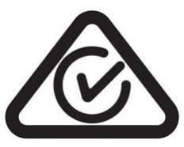 | A trade mark owned by the electrical regulator (Regulatory Authorities (RAs)) and Australian Communications Media Authority (ACMA)
 | States that the product is approved by the Ministry of Internal Affairs and Communications in Japan |  | Indicates proof of conformity to EU 2017/745 Medical Devices Regulation and applicable standards.
 | RoHS label |  | Do not drop
 | Consult instructions for use |  | Refer to instruction manual/ booklet
 | Caution |  | Warning
 | Medical device |  | UDI-DI
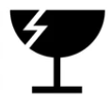 | Fragile |  | Keep away from moisture
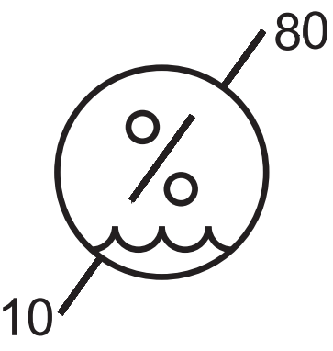 | Humidity limitation | 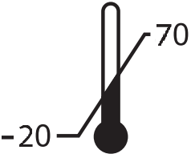 | Temperature limitation
 | UN3481, Lithium-ion battery contained in equipment including lithium ion. polymer batteries | IP21 | This item has protection from dripping water/condensation
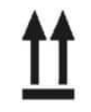 | This side up | 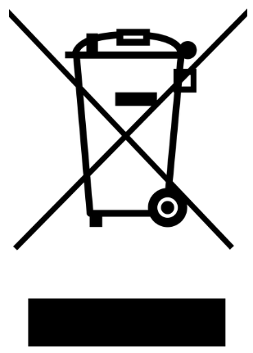WEEE | 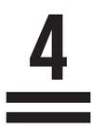 | Maximum stacking
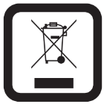 | Waste from Electrical and Electronic Equipment (WEE). This symbol [crossed-out wheeled bin WEEE Annex Ⅳ] indicates separate collection of waste electrical and electronic equipment in the EU countries. Please do not throw the equipment into the domestic refuse. Please use the return and collection systems available in your country for proper disposal of this product.

Warnings and Precautions
The contents of this manual may differ from the actual product, depending on the software version of the product, the specifications of the model, and the user's settings. Do not use the product for any purpose other than the intended purpose. Use with caution as the product may be damaged if impacted.


Caution Information
- Keep the Dot Pad 320 dry at all times. Using the product in high-humidity environments or allowing it to get wet may result in malfunction.Do not use the product in hot or humid conditions. If the product becomes wet, turn off the power and allow it to dry completely before use.Do not place the product for extended periods on blankets, carpets, near household appliances, heating devices, or in direct sunlight (e.g., inside a closed vehicle during summer), as this may cause deformation, damage, or even explosion.If the product temperature rises rapidly, discontinue use immediately and contact customer service.
- Operating Environment: 0°C ~ +40°C
- Storage and Transportation Environment: -20°C ~ +70°C
- For long-term storage, keep the Dot Pad 320 in a cool and dry environment below 35°C.
Although there is no risk of fire at temperatures up to 70°C, prolonged exposure to temperatures above 35°C may permanently reduce the battery’s maximum capacity.
- The Dot Pad 320 contains built-in magnets. Do not place it near magnetic objects or metal items, as this may cause damage to the product. Do not place the charging port near metal objects such as necklaces, keys, coins, nails, or watches. If metal objects come into contact with the charging port and cause a short circuit, there is a risk of explosion. Do not store the Dot Pad 320 near strong magnetic fields. Magnetic fields may affect the device and cause malfunction.
- The Dot Pad 320 has passed Electromagnetic Compatibility (EMC) and Radiated Spurious Emissions (RSE) tests. However, environmental or situational factors may still cause interference or affect signals from nearby devices. This may result in heat generation or malfunction.Using the Dot Pad 320 with non-approved accessories may cause malfunction.
- Do not use the Dot Pad 320 in areas where the use of electronic devices is prohibited, such as on aircraft. Electronic and communication devices may be affected by electromagnetic interference.
- Using the Dot Pad 320 on an unstable surface (such as near the edge of a table) or in dusty environments may allow foreign particles to enter the device, which can interfere with its operation.
- Use only accessories provided or approved by Dot Inc. Using third-party accessories may cause malfunction and may void the warranty provided by Dot Inc. The included USB C-to-C cable is a dedicated data cable intended for connection to the USB-C data connector. Please note that a power adapter is not included. When charging the device, it is recommended to use an adapter that complies with applicable safety standards (e.g., IEC 60601-1 for medical electrical equipment).
- The wireless transmission power of the Dot Pad 320 complies with applicable radio frequency (RF) standards. However, if the voltage or temperature falls outside the specified operating range, the wireless transmission may become unstable and affect performance.As wireless interference may occur during operation, the Dot Pad 320 must not be used for safety-critical applications or medical purposes where human life may be at risk. The manufacturer is not responsible for any radio or TV interference caused by unauthorized modifications or changes to this equipment. Such modifications may void the user’s authority to operate the device.
- The Dot Pad 320’s wireless communication antenna has passed the Specific Absorption Rate (SAR) test measured by qualified equipment. If any abnormal operating method is applied, the product’s antenna performance may change.
- The Dot Pad 320’s Short Range Wireless Communication function satisfies the data transfer security standards. However, if the software or firmware is modified or changed without authorization, the product’s data transfer security may operate abnormally.
- If you apply strong force to the device, place heavy objects on top, etc., it may cause an impact to the product. This may damage your device, cause malfunction, or shorten its lifespan. This may also cause overheating, combustion, or fire. When not in use, store it in a safe place to avoid shock and damage to the device.
- Applying pressure while the braille cells are in motion may cause the product to operate improperly. This is not considered a malfunction. In such cases, remove your hand and try printing the desired image again.
- If the product is used in the opposite direction, it may not be able to represent the image or braille correctly.
- Some product specifications are subject to change without notice to better serve you.
- If the Dot Pad 320’s firmware provided by Dot Inc. is changed or applied to the product through an unofficial channel, it may cause damage to the product or cause errors. In this case, the warranty service is voided.
- When charging the Dot Pad 320, the product temperature may rise, and if the temperature of the battery rises above a certain level, the charging may be automatically stopped for safety reasons.
- When not in use for a long time, disconnect the charger from the Dot Pad 320 and store it in a safe place. When storing the charger, be careful not to severely fold or twist the USB cable. If the USB cable is stored or used with an excessive fold or twist, the silicone coating of the cable can be stripped off or the cable may break and cause a failure or accident.
- If you want to use the Dot Pad 320 after a long period of unuse, please use it again after fully charging. Once the device is fully charged, disconnect the charger from the outlet and the device to avoid unnecessary power consumption.
- Do not change, modify, or expose the Dot Pad 320 to liquids. Please note that it may explode if the battery is forcibly removed.
- If the product gets heated while charging, please wear gloves or use a tool other than your body to separate the charger and the Dot Pad 320. Overheating may cause damage to the product. If the device overheats while charging, please unplug the USB charging cable and contact a Dot Inc. licensed service center.
- This equipment must be installed and operated in accordance with provided instructions and the antenna(s) used for this transmitter must be installed to provide a separation distance of at least 20 cm from all persons and must not be co-located or operating in conjunction with any other antenna or transmitter.
- The Dot Pad 320 has passed all qualification tests mentioned above by qualified laboratories. However, if the product is placed in different conditions that could cause functional errors or is applied to atypical operation methods, the product may operate abnormally. It is advised to turn off the device, disconnect the power, stop using the device, and contact customer service.

Warning
1. Do not use the Dot Pad 320 while it is charging.
To eliminate the risk of electric shock, the device is designed not to operate while connected to a power adapter during charging. To use the device, make sure to disconnect the charging cable.

2. Do not use the Dot Pad 320 during severe thunderstorms.
During lightning or thunder, refrain from using the product and disconnect the charger from the power source. Continued use may result in injury, fire, or device malfunction
3. Do not disassemble or modify the product under any circumstances.
Do not subject the product to impact or shock. This may result in electric shock, short circuit, or fire. Warranty service does not cover damage caused by disassembly.
If service is required, contact your local distributor’s customer service or Dot Inc.
Do not use the product if it is damaged or malfunctioning, as this may cause fire, burns, or electric shock. In such cases, discontinue use immediately and contact customer service.

4. Use only the correct power cable and a suitable adapter.
Ensure that the USB cable is properly connected to prevent it from becoming loose. Do not bend, pull, heat, cut, or loosely connect the cable, as this may cause fire or electric shock.
Disconnect the charger when it is not in use. Using the device while charging may pose a risk of electric shock.
Do not use unauthorized chargers. This may damage the battery and cause injury to the user or damage to the device. When disconnecting the adapter, hold the adapter itself rather than pulling the cable. Pulling the cable may damage the internal wiring, resulting in charging failure.

5. Do not use any chemical substances.
When cleaning the Dot Pad 320, do not use chemicals such as alcohol or benzene, as this may cause fire.
If the product or charger becomes contaminated, wipe it gently with a soft cloth.

6. Exercise special caution around children and pets.
Keep the product, charger, and all components out of reach of children and pets. If the product, charger, or components are placed in the mouth or subjected to impact, there is a risk of electric shock or exposure to electromagnetic fields.
Ensure that children and pets do not swallow any part of the product or accessories, as this may cause choking, explosion, or fire.

7. Do not use in explosive environments.
Do not use the product in hazardous or explosive environments. The device may interfere with high-frequency equipment.Do not place the product on unstable surfaces, such as vibrating or inclined areas. If the device falls, it may result in injury or damage to the product.
.
8.Caution regarding interference with implantable medical devices
This device contains magnets and wireless communication components. Patients using implantable medical devices such as pacemakers or defibrillators should consult a medical professional before use, as there is a risk of interference from radio waves and magnetic fields.
9. Fire hazard precautions
Do not cover or wrap the Dot Pad 320 with materials such as blankets during use or charging.
Do not dispose of the device with general household waste, as this may cause fire, explosion, or environmental pollution.

10. Avoid excessive contact in heated conditions
If the surface temperature of the product rises above a safe level, discontinue use. Prolonged contact under such conditions may cause burns or skin discoloration.If the outer protective cover is damaged or if an allergic reaction to the product materials occurs, stop using the product immediately and consult a physician.

1. About the Dot Pad 320 (DPA320X)

1.1. Dot Pad 320
The Dot Pad 320 is a tactile graphic information display that can simultaneously represent Braille text and tactile graphics for patient with visually impairment and blindness. The Dot Pad 320 is beneficial in educational and rehabilitative settings focusing its usage:
As a tactile display, Dot Pad 320 is compatible with screen readers such as JAWS, NVDA and Voiceover. Additionally, it must be connected to software services developed by Dot or third-party developers using Dot's SDK, allowing for versatile usage across various platforms and applications.
- Devices available to connect with VoiceOver
- iPhones running iOS versions 15.2 and later
- iPads running iPadOS versions 15.2 and later
- MacBooks running MacOs version 13.3 and later
Warning: This tactile graphic information display is intended to be connected to input signals from iOS devices via BLE that comply with the relevant IEC standard (e.g., IEC 62368-1 for IT equipment and IEC60601 series for medical electrical equipment). In addition, all such combination systems must comply with the IEC 60601-1-1 standard or clause 16 of the 3rd edition of IEC 60601-1, safety requirements for medical electrical systems. Any person who has formed a combination system is responsible for ensuring that the system complies with the requirements of IEC 60601-1-1 or clause 16 of the 3rd edition of IEC 60601-1. If in doubt, consult a qualified engineer or your local representative.

Intended Patient Population: Not applicable.

1.1.1. Components of the Dot Pad 320
When you purchase the Dot Pad 320, it includes the following components:
Configuration and Support | Dot Pad 320 | 1
Configuration and Support | 300-cell Protection Skin | 3 each
Configuration and Support | 20-cell Protection Skin | 3 each
Configuration and Support | Braille Quick Guide (Eng) | 1
Configuration and Support | USB Cable 1.2M | 1
Configuration and Support | TPU Protective Cover | 1
Configuration and Support | Dot Pad 320 Carry Pouch | 1
Configuration and Support | Warranty Period | 2 years

1.2. Dot Pad 320 Appearance
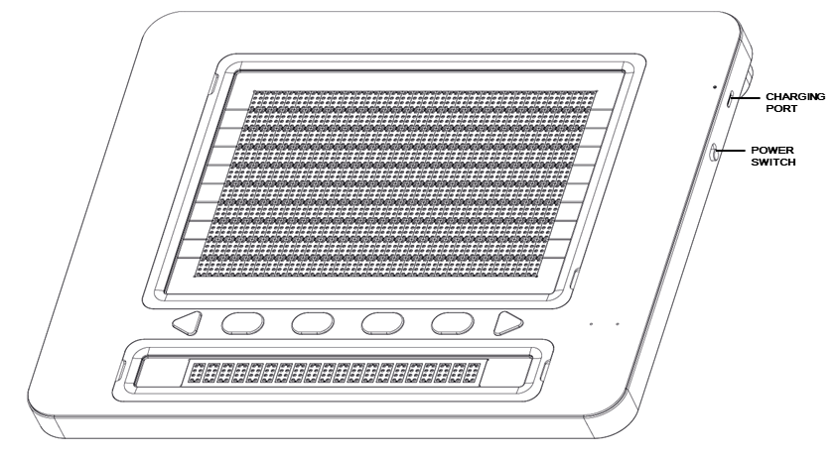
When you take the Dot Pad 320 out of the box and place it on a desk, your Dot Pad 320 is correctly positioned when the main body is slightly inclined downward toward you.
.

1.2.1 Dot Pad 320 Top View
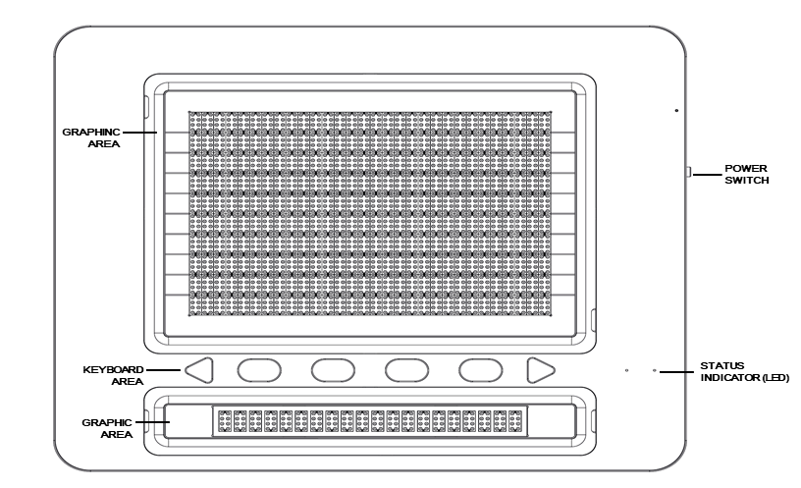
When the Dot Pad 320 is properly oriented, the top surface consists of the following components, arranged from closest to farthest from the user:
- Text Display Area: This area consists of 20 braille cells arranged in a horizontal rectangular frame. Each cell follows the standard braille spacing, allowing for the simultaneous display of up to 20 braille characters.
- Control buttons Area: From left to right, the control buttons area includes the Previous Panning Key, Function Keys (F1, F2, F3, F4), and the Next Panning Key.
- Tactile indicators are provided on the F1 and F4 keys to distinguish them from the others. The panning keys are triangular in shape, making them easily distinguishable from the oval-shaped function keys.
※ The panning keys are used to navigate to the previous or next line, based on the 20-cell braille text area.
- LED Status Indicator: Located at the far right of the control buttons area, the LED status light communicates Your Dot Pad 320 status such as power, Bluetooth connection, and charging via color and blinking patterns.
- Graphic Display Area: This is the largest area on the front of the Dot Pad 320, consisting of 300 8-dot braille cells (30 columns × 10 rows).
The cells in this area are more densely packed than those in the text area, with evenly spaced pins in all directions, enabling precise tactile rendering of graphical content.
It can display real-time screen content from iPhones or iPads, as well as tactile graphics from dedicated applications compatible with the Dot Pad 320.

1.2.2. Dot Pad 320 Right Side
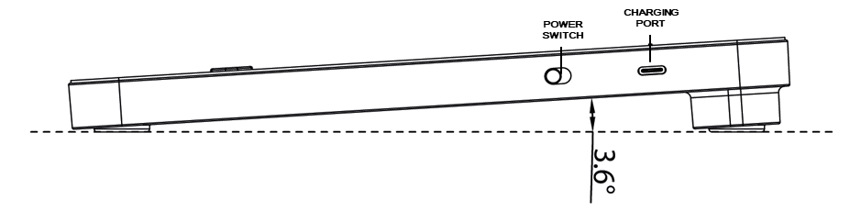
On the right side of the Dot Pad 320, you’ll find a USB-C port labeled with the braille character for the letter “p.” This port is dedicated solely to charging the device and does not support data transfer. Beneath the USB-C port is the power switch. To turn on your Dot Pad 320, slide the switch forward away from you, you’ll feel a long vibration as confirmation. To turn it off, slide the switch backward toward you.

1.2.3. Dot Pad 320 Left Side
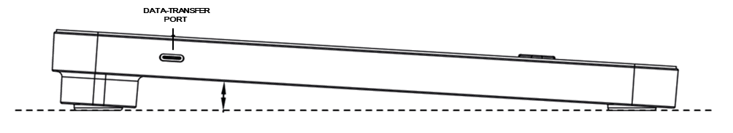

The Dot Pad 320’s left side has a USB-C port labeled “d.” In Braille (dots 1, 4, and 5), it connects to screen readers and apps or performs firmware updates with Dot Canvas.
※ Please note: This port does not support charging. To charge your Dot Pad 320, always use the USB-C port on the right side.

1.2.4. Dot Pad 320 Bottom Surface
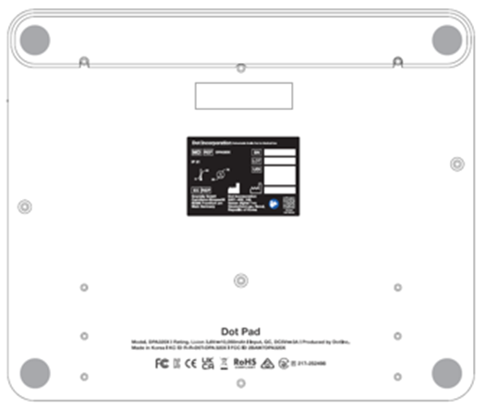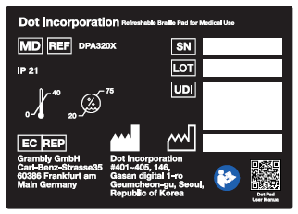
On the bottom side of the Dot Pad 320, you will find the battery compartment and screws that allow access to the protective film covering the braille cells. The built-in battery is not user replaceable. If replacement is necessary, it must be performed by Dot Inc. or an authorized service provider.
The protective film on the braille cell surface can be replaced by removing the screws located on the bottom of your Dot Pad 320.
For more information or assistance regarding the protective film, please contact Dot Inc. customer support.

1.3. Specifications

General Specifications
1) Hardware
Item | Description
Product Model | DPA320X
Dimensions | 273.6 (W) × 228.5 (D) × 28.7 (H) mm
Weight | 1,200 g (±10%)
External Connections | Power input (USB-C, DC 5V / 3A) – 1 ea (adapter sold separately)  USB data cable (C to C) – 1 ea

Braille & Display
Item | Description
Tactile Graphic Area | 300 cells
Braille Text Area | 20 cells
Braille Cell Configuration | 320 cells (30×10, 20×1)
Braille Pin Stroke Height | 0.6 ± 0.05 mm
Protective Skin | Graphics area (300 cells) / Text area (20 cells)

System Specifications
Item | Description
Processor | ARM Cortex-M4, 32-bit, 120 MHz
RAM | 64 KB
Flash Memory | 128 KB
External Memory Support | Not supported
Wireless Connection | Bluetooth 5.0 (Low Energy)
Sensor | None
Camera | None

Buttons & Interface
Item | Description
Function Keys | 4 ea
Panning Keys | 2 ea (Left, Right)
Power Switch | 1 ea (ON/OFF)
Keyboard | None

USB Interface
Port | Description
USB-C (Left) | Data & firmware updates
USB-C (Right) | Power input & charging (DC 5V / 3A)

Electrical Specifications
Item | Description
Main Power | DC 5V, Min. 3A
MCU Power | DC 3.3V, 150 mA
Battery | Li-ion battery pack, 3.60V, 10.05Ah, 36.18Wh (1S3P)

Power Requirements
Item | Min. | Max. | Unit
Input Voltage | -0.5 | 5 | V
USB Communication Voltage | -0.5 | 5 | V

Environmental Conditions
Item | Range
Operating Temperature | 0°C ~ +40°C
Storage Temperature (Allowable) | -20°C ~ +70°C
Recommended Storage Temperature | -20°C ~ +35°C
Operating Humidity | 20 ~ 75% R.H.
Storage Humidity | 10 ~ 80% R.H.
Operating Pressure | 500 ~ 1060 hPa

Recovery Conditions
Item | Description
Recovery from Low Temperature | 24 hours (for complete drying)

2) Software
Bluetooth Communication

Item | Description
Specification | Bluetooth 5.0 (Low Energy, up to 10 kbps)
Output Power | 0 dBm
Data Rate | 10 kbps
Profiles | GAP, GATT, SM, L2CAP, Integrated Public Profiles
Sensitivity | -90 dBm
Frequency Band | 2.402 GHz ~ 2.480 GHz

3) Battery

Item | Description
Battery Type | Li-ion battery pack, 3.60V, 10.05Ah, 36.18Wh (1S3P)
Charging | DC 5V / 3A
Maximum Operating Time | Up to 4 days (based on 3 hours/day usage)
Full Charging Time | Max. 8 hours
Recommended Replacement Cycle | 1.5 years

- Hardware
Hardware Specifications | Product Model | DPA320X
Hardware Specifications | Tactile Graphic Area | 300 cells
Hardware Specifications | Braille Text Area | 20 cells
Hardware Specifications | Protective Skin | Graphics area (300 cells) /  Text area (20 cells)
Hardware Specifications | Processor | ARM Cortex-M4 32-Bit 120MHz
Hardware Specifications | RAM | 64KB
Hardware Specifications | Flash Memory | 128KB.
Hardware Specifications | External Memory Support | Not supported.
Hardware Specifications | Wireless Connection | Bluetooth LE V5.0
Hardware Specifications | Sensor | None
Hardware Specifications | Camera | None
Exterior Specifications | Size (mm) | 273.6W) x 228.5(D) x 28.7 (H)
Exterior Specifications | Weight (g) | 1,200g (±10%)
Keyboard and Buttons | Function Keys | Function Key 4ea
Keyboard and Buttons | Panning Keys | 2ea (Left, Right)
Keyboard and Buttons | Power Switch | 1ea (ON/OFF)
Keyboard and Buttons | Keyboard | None
USB Interface | USB-C (left) | Data & Firmware updates
USB Interface | USB-C (right) | charging
Audio and Video Interface | Speaker | None
Audio and Video Interface | Microphone | None
Audio and Video Interface | HDMI Video Output | None
Temperature Limitation | Operating Temperature | 0°C ~ +40°C
Temperature Limitation | Storage Temperature | -20°C ~ +70°C
Temperature Limitation | Recommended Temperature | -20℃ ~ +35℃
Standby Time for Recovery to Operable Temperature | Recovery from min. Temperature | 24 hours  (for complete drying)
Standby Time for Recovery to Operable Temperature | Recovery from max. Temperature | 24 hours  (for complete drying)
Humidity Limitation | Operating Humidity | 20 ~ 75% R.H.
Humidity Limitation | Storage Humidity | 10 ~ 80% R.H.
Atmospheric pressure | Operating Atmospheric pressure | 500 ~ 1060 hPa
Atmospheric pressure | Storage Pressure Atmospheric | 500 ~ 1060 hPa
Charging and Battery | Battery | LI_ION BATTERY PACK, 3.60V, 10.05Ah, 36.18 W[1S3P]
Charging and Battery | Charge | DC 5V / 3A

- Software
Communication (Bluetooth) | Specification | Bluetooth V5.0 (LE up to 10Kbps)
Communication (Bluetooth) | Output Power | 0 dBm
Communication (Bluetooth) | Data Rate | 10 kbps
Communication (Bluetooth) | Profile | GAP, GATT, SM, L2CAP and Integrated Public Profiles
Communication (Bluetooth) | Sensitivity | -90 dBm
Communication (Bluetooth) | Frequency Band | 2.402GHz ~ 2.480GHz

- Battery
Battery Health | Maximum Operable Time  * Applicable within intended usage | 4 Days (usage rate: 3 hours/day)
Battery Health | Optimal hours for full battery charge | Max. 8 hours
Battery Health | Recommended battery replacement | 1.5 years

* Device does not work while the internal battery is charging.

- Packaging
- Packaging Default Configuration

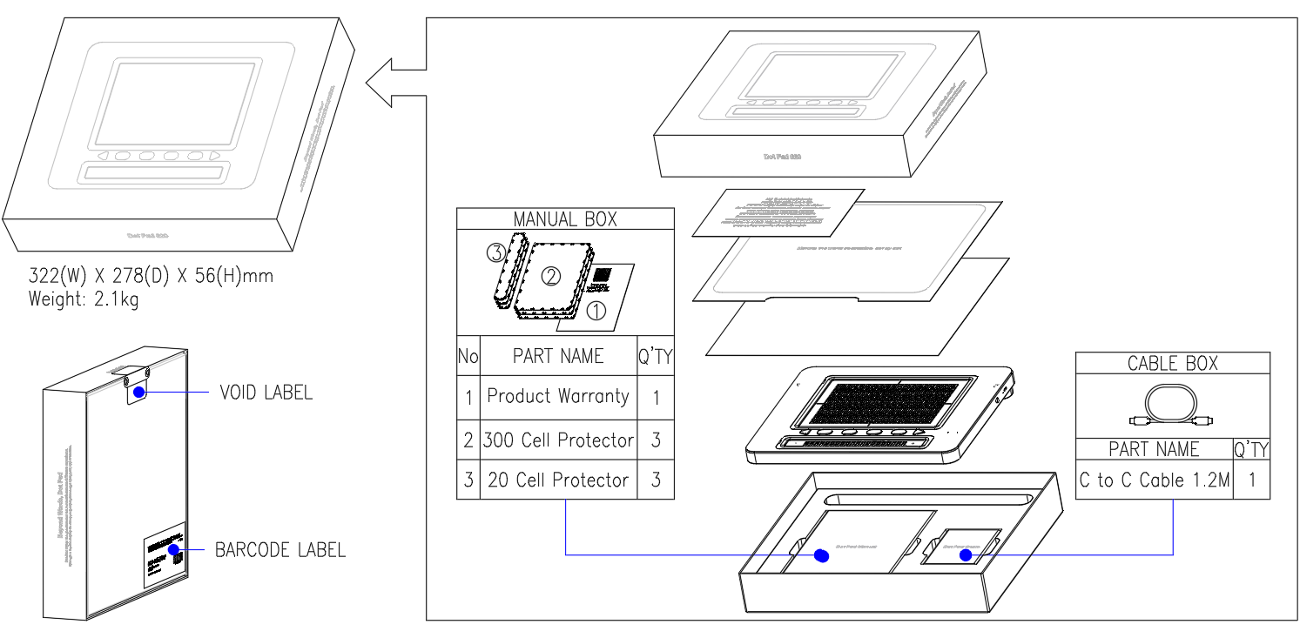

- Out Box
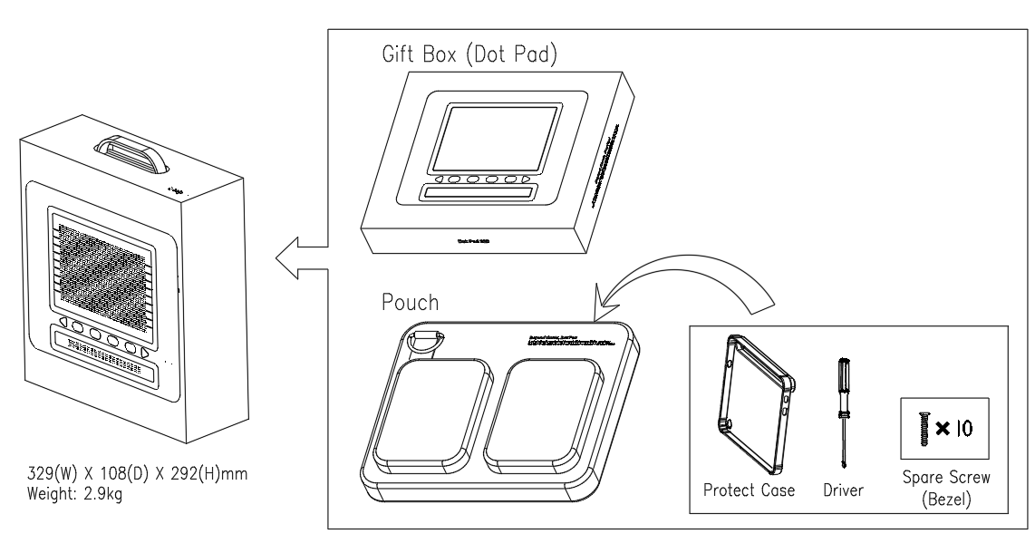

- Carton Box
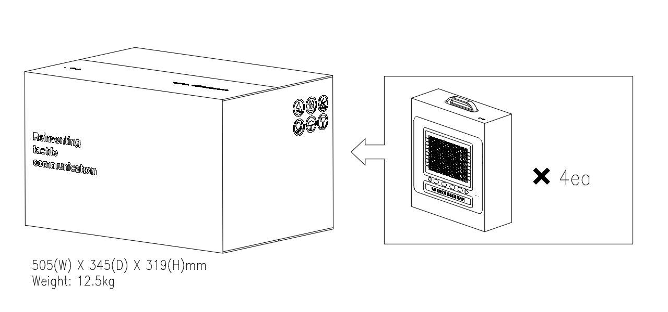
- Packaging Labels

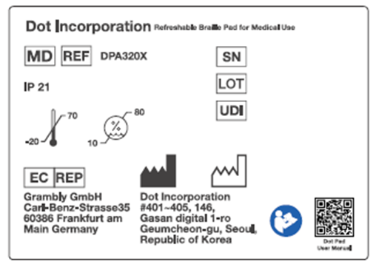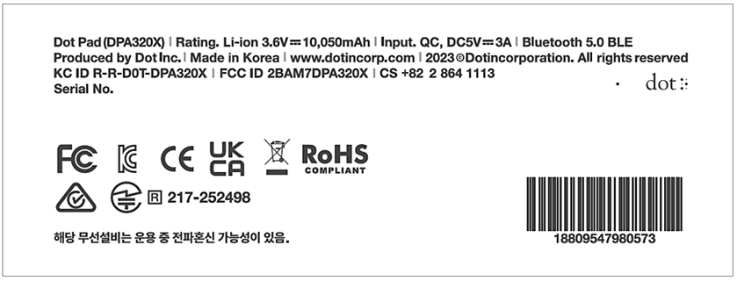

- Electric
- Insulation Diagram
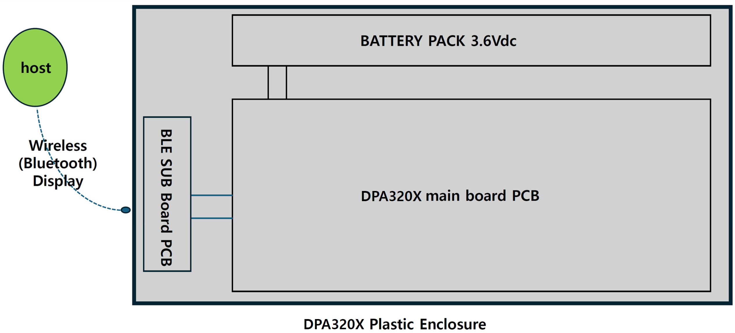

2. Basic Functions
In this section, you will get to know the different vibration patterns to test the Dot Pad 320’s state and ways to check the battery level.

2.1. Understanding Dot Pad 320 LED Signals
- When Connecting the Dot Pad 320 to a Device After Powering On
LED Color / State | Explanation
Blue / Blinking | Searching for device
Blue / Turned on | Connected to device

- When Charging the Dot Pad 320
LED Color/State | Explanation
Red / Blinking | Charging error
Red / Turned on | Charging
Red / Turned off | Fully charged or device is turned off

2.2. Understanding Device Information through the Dot Pad 320’s Vibration Signals
The vibration pattern of the Dot Pad 320 informs the user regarding the Dot Pad 320’s battery level, Bluetooth connection status, power status, etc.
Status | Vibration Pattern
Power On | One long vibration
Power Connection | Once the power cable is connected successfully, vibration will indicate the battery status
Battery Level | 1~5 vibrations (according to the battery level)
Bluetooth Connected | Two long vibrations

To check the battery level of the Dot Pad 320, make sure your Dot Pad 320 is powered on.
Then, press and hold both the Previous and Next Panning Keys simultaneously for at least 1.5 seconds, and release.
The battery level is divided into five levels and can be checked through vibration and tactile feedback.
- When Bluetooth is not connected, the battery level is displayed on the 20-cell text display as tactile output for 7 seconds, along with vibration feedback.
- When Bluetooth is connected, only vibration feedback is provided, and no information is shown on the 20-cell display.
The battery level is divided into five levels, and each level is indicated by the number of vibrations.
The number of vibrations corresponds to the battery level: 5 for Level 5, 4 for Level 4, and so on down to 1 for Level 1.
Number of Vibrations | 5 | 4 | 3 | 2 | 1
Battery Level | Level 5 | Level 4 | Level 3 | Level 2 | Level 1
In addition to vibration feedback, the battery level is also displayed tactilely on the 20-cell text display.
The battery level is divided into five levels (Level 1 to Level 5), and the cells are filled sequentially according to the current battery level.
Tactile Feedback | 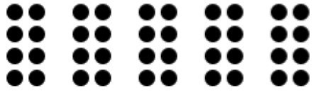 | 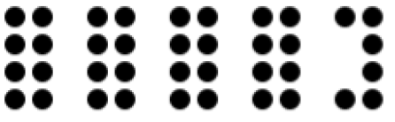 | 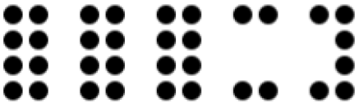 | 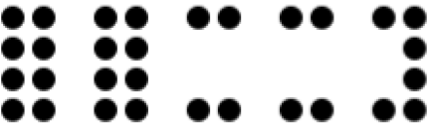 | 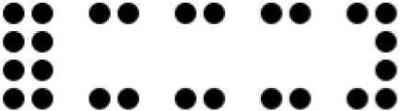
Battery Level | Level 5 | Level 4 | Level 3 | Level 2 | Level 1
If your Dot Pad 320 is used extensively while the battery is at Level 1, it may become completely discharged and shut down unexpectedly.
If your Dot Pad 320 vibrates twice every 5 minutes, it indicates that the battery level is low, and it needs to be charged. When this feedback occurs, please charge fully up to Level 5 before further use. Charging from this low-battery state to Level 5 typically takes approximately 2 hours and 30 minutes.

3. Usage of Dot Pad 320 with VoiceOver
The Dot Pad 320 is available in conjunction with VoiceOver, the screen reader of iPhone/iPad/MacBook. Once the connection between the VoiceOver function and Dot Pad 320 is successful, the image element is displayed in the 300-cell graphics area of the Dot Pad 320 and the voice guidance is displayed in braille in the 20-cell braille text display area regarding the object that VoiceOver focuses on.

Dot Pad 320 together with VoiceOver can be used to review graphs and charts directly from the monitor. Patients can have a detailed understanding of their current illness and easily view their clinical history via graphical information and Braille.

3.1 Connecting/Disconnecting with an iPhone/iPad
Before connecting the Dot Pad 320 to your iPhone/iPad, your iPhone/iPad must have an operating system of iOS 15.2/iPadOS 15.2 and above. Here's how to check your operating system version:
- Go to [Settings] > [General] > [Software Update]
- Make sure the iPhone/iPad is running a version of iOS 15.2/iPadOS 15.2 or above.
- If you have an operating system below iOS 15.2 installed, click the Software Update button that appears at the bottom of the screen to proceed with the operating system update.
- If the update doesn't appear, make sure your iPhone/iPad supports iOS 15.2/iPadOS 15.2.

3.1.1. Connecting an iPhone/iPad With the Dot Pad 320
If your iOS or iPadOS is 15.2 or above, follow these steps to connect the Dot Pad 320.
- Turn the Dot Pad 320 on. The Dot Pad 320 will be on connection standby.
- Go to [Settings] > [Accessibility] > [Voiceover] > [Braille]
- At the bottom of the screen, you'll see a list of braille displays that you can connect to. (Use the four-finger tab to move to the end of the screen.)
- Use the one-finger upward or downward swipe gesture to locate and select the "DPA320X xxxx (unique code for each device)" device. This is the name of the Dot Pad 320 device.
- When connected, VoiceOver on your iPhone or iPad will indicate that you're connected to a braille display, and the Dot Pad 320 will vibrate two times.
- The Dot Pad 320 is connected successfully.

3.1.2. Disconnecting the Dot Pad 320 from an iPhone/iPad
- Go to [Settings] > [Accessibility] > [Voiceover] > [Braille]
- Scroll to the bottom of the screen and find the "DPA320X xxxx (unique code for each device)" device.
- Use Voiceover's rotor function by rotating two fingers clockwise or anticlockwise to go through options, to find [action]. (By default, the rotor value is automatically placed as “action”.)
- Swipe one finger up or down to select [More Information]
- Double-tap with one finger to activate [More Information].
- Find and run [Forget this Device].
- Go to the iPhone/iPad Bluetooth menu, then turn off Bluetooth and turn it back on again.
- When the Dot Pad 320 is disconnected, VoiceOver outputs a sound that the Dot Pad 320 is disconnected.
- The Dot Pad 320 is disconnected from the iPhone/iPad.
※ If the Dot Pad 320 is automatically connected even though you have run Clear Device, click Clear Device again. Please turn off the Bluetooth of the iPhone/iPad connected to the Dot Pad 320 and turn it back on again.

3.2. Default Key Settings
The Function keys can be used when connected to VoiceOver:
- F1: Moves from the currently focused object to the previous object. This is equivalent to swiping with one finger to the left when connected to VoiceOver.
- F2: Go to Home.
- F3: Executes the currently focused object. This is equivalent to a double tap with one finger when connected to VoiceOver.
- F4: Moves from the currently focused object to the next object. This is equivalent to a one finger swipe to the right when connected to VoiceOver.
※ Default Key Settings may differ depending on the Software (Dot Canvas App/Web) used.

3.3. Connecting iPhone/iPad With the Dot Pad 320 to Read Braille and Tactile Images
The Dot Pad 320 can display braille text and graphics. Braille text is displayed on the braille cells below the large braille display, and the graphic appears in the largest area. This section walks you through VoiceOver to view basic braille and graphic information.

3.3.1. Reading Braille Text
The braille text area displays texts and its dedicated symbols that the VoiceOver reads out; if the text is too long, use the Previous and Next panning keys to move and read the next braille text line.

3.3.2. Displaying the Image
The Dot Pad 320 displays images that the VoiceOver determines as an image.
- Move to the home screen with the Dot Pad 320 connected.
- Focus on any application on the home screen.
- The application icon will appear on the graphic area while the text will appear on the braille text area

3.4. Reading Images in Detail with Rotors

3.4.1. Adding Image Navigation Options to the Rotor
You can adjust the line thickness of the image, enlarge the image, and more with the functions that VoiceOver supports. To use the related features, you need to add the functions to the rotor.
- Go to [Settings] > [Accessibility] > [VoiceOver] > [Rotor]
- Scroll the screen to find [Braille Zoom], [Braille line thickness], [Pan braille horizontally], [Pan braille vertically], [Invert braille], and double tap each item to select it.
- When you see the message "Selected" the function has been added to the rotor.

3.4.2. Using Image Inversion
Inverting an image is a function that converts an image’s outline from being embossed to being engraved.
- Focus on any image (e.g. application icon on the home screen).
- Notice that the image is displayed in the Dot Pad 320 graphics area.
- Move the rotor of the VoiceOver and place it to [Invert braille].
- Swipe down with one finger to activate Invert.
- The output image of the image on the Dot Pad 320 is reversed.
- If you want to revert the image to default, select [Invert braille] on the rotor, and then swipe up with one finger.

3.4.3. Enlarging an Image
VoiceOver provides the function to zoom in the image on the Dot Pad 320 from a range of default image scales from 1x up to 10x.
- Focus on an object that contains an image (e.g. focus on any application icon on the home screen).
- In the rotor options, select [Braille Zoom].
- Swipe one finger up and down to adjust the magnification ratio.
- The currently focused graphic appears in the graphics area to match the magnification ratio you specify.

3.4.4. Scrolling Images Horizontally and Vertically
If the image is enlarged at a size that it is difficult to display it all at once in the Dot Pad 320 graphics area, you can scroll the image left, right, up, and down to see the full picture of the image using [Rotate braille horizontally] and [Rotate braille vertically].
※Note: This feature can be used with the image magnified by more than 1.5 times.
- Focus on the object that contains this image. (e.g. any application on the home screen)
- Align the rotor option with [Rotate braille horizontally].
- Swipe down with one finger to increase the value and scroll left.
- Swipe up with one finger to lower the value and scroll right.
- If you do the same in [Rotate braille vertically], the image displayed in the Dot Pad 320 scrolls up/down.

3.4.5. Adjusting the Image Line Thickness
You can adjust the line thickness of the images displayed on Dot Pad 320.
- Focus on an object that contains an image. (e.g. home screen application)
- In the rotor options, select [Braille Line Thickness].
- Swipe one finger up /down to adjust the line thickness.
- The default value is 0.3 and you can adjust the values from 0.1 to 1.0.

3.5. Viewing Images Using Voiceover Recognition

When Voiceover does not recognize any object as an image, image information can be collected using artificial intelligence (AI) to view the relevant image on the Dot Pad 320. VoiceOver and Dot Pad 320 outputs the analyzed image.
※To activate this function, the device must be iOS/iPad OS 14 and above.

3.5.1. Creating Image Recognition Gestures
To use VoiceOver recognition to send an image to display on the Dot Pad 320, you must manually add a gesture that allows you to run VoiceOver recognition; here's how:
- Go to [Settings] > [Accessibility] > [VoiceOver] > [Recognize VoiceOver].
- Locate [Image Description] and make sure that it is turned on.
- If the image description is off, double tap the [Image Description] button to switch it to “On”.
- The data required for the image description is then downloaded.
- After completing the download, use the “Back” gesture or press [Back] to exit out to [VoiceOver].
- In this guide, we're going to set the [four-finger tap] to launch VoiceOver Recognition.
- Go to [Commands] > [Touch Gesture] > [Four-finger tap] > [Image Description] in the VoiceOver category and select.
- If it has been added successfully, a four-finger tap will activate AI to describe the contents of the image on the current screen.

3.5.2. Using the Image Recognition Function to View an Image
If your Dot Pad 320 is connected to your iPhone/iPad and VoiceOver Recognition is enabled, manually launch the image description function using a four-finger tap after VoiceOver is focused on the image you want to print. You can view the analyzed image along with a description of the image by sending it to the Dot Pad 320.

3.6. Customizing the Dot Pad 320 Keys
The panning and function keys on the Dot Pad 320 can be modified to suit the characteristics of your personal usage. For example, you can modify the F1 key from “Move to the previous item” to “Toggle the screen curtain”.
- With your device connected to the Dot Pad 320, go to [Settings] > [Accessibility] > [VoiceOver] > [Braille].
- Find and focus on "DPA320X xxxx (unique code for each device)".
- Adjust the rotor to [Action]. (Rotor default setting is usually set to action.)
- Swipe one finger up/down to select and double tap to go to [More Information]
- Find and select [Braille Command] to find the [Option] category.
- Select the desired option from [Braille], [Devices], [Interactive], [Keyboard], [Navigation], [Rotor], [VoiceOver]. This guide will use [Navigation] as an example.
- Find and select [Browse] > [Next paragraph] > [Assign a new braille key]
- When the pop-up appears, customize a key to perform [Previous Paragraph] on the Dot Pad 320.
- This guide uses the Previous panning (left arrow) key.
- If you press the Previous panning (left arrow) key, a warning message appears that it is already in use.
- To ignore and modify the key, run [Assign a new braille key].
- Now the panning key performs the new function of moving to the previous paragraph. To keep the key intact, use the Back gesture in VoiceOver to exit the warning pop-up.

4. Optional Software & Screen Reader Integration
The Dot Pad 320 (DPA320X) is more than a braille display; it is a multi-platform tactile workstation. By using the following optional software and drivers, you can unlock advanced tactile graphics and multi-line braille across Windows and Apple ecosystems.

4.1 Introduction to Dot Canvas (App)
The Dot Canvas (App) is an application for iPhones/iPads that can be used in conjunction with the Dot Pad 320 to display information (dots, lines, shapes, pictures, text, etc.) Though functional on iPhones, Dot Inc. suggests using the app primarily on iPads, given its development focus. Dot Canvas (App) allows visually impaired and blind users to create and modify their own tactile graphic content, save it to My Drawings and their Personal Drive, or share it to the Public Drive. Saved and shared tactile graphic content can be easily loaded and displayed on the Dot Pad 320.
Dot Canvas APP
- Operating Systems: iOS/iPadOS
- Download: Available on the Apple app store by searching for ‘Dot Canvas.’
※ For Optimal drawing experience, using the app with an iPad is recommended.

4.2 Introducing Dot Canvas (Web)
The Dot Canvas (Web) is a Dot Pad 320 optimized web graphic editing tool where users can create, save, and share digital tactile graphics. With the tools available, non-experts can also create and save their own tactile graphics and use and edit the tactile graphics that are saved on the Dot Cloud.
Users can upload image files onto Dot Canvas (Web) to convert it into tactile graphics automatically. With Dot’s braille translator, it is possible to print braille from texts on the Dot Pad 320 in real time. Dot Canvas (Web) allows multiple units of Dot Pad 320 to be connected and displayed at once.
※ Dot Canvas Web
- Hardware Requirements: PC with Bluetooth support
※ Dot Canvas Web is optimized for use with the Chrome browser

4.3 Integration with NVDA (Windows)
The NVDA Dot Pad 320 Driver enables a unique dual-display experience on Windows.
Dual-Cursor Navigation: * The 20-cell display tracks the System Focus (your active cursor/typing).
The 300-cell display tracks the Navigator Object (the surrounding context or images).
Tactile Charts: In Excel or PowerPoint, press CTRL + Alt + 5 to convert data into a tactile bar graph instantly on the graphic area.
Navigation Shortcuts:
- F1 / F4: Scroll back/forward in multi-line braille.
- Left Pan + F1: Move to the previous item.
- Right Pan + F4: Move to the next item.
Configuration: Set Braille Tethering to "System Focus" via NVDA + CTRL + T to prevent confusion between the two display areas.
※ System Requirements
Operating System: Windows 8.1 or higher
※ Windows 10 or higher recommended.
NVDA Version: NVDA 2023.4 or higher
※ NVDA 2024.1 or higher recommended.

4.4 Integration with JAWS (Windows)
JAWS 2025+ provides professional-grade braille features for the Dot Pad 320.
- Split Braille: Press F1 + F4 to divide the 300-cell area into two independent regions (e.g., active document on top, buffered reference text on bottom).
- Table Reading: Use Cropped Mode to maintain vertical alignment in spreadsheets, allowing you to feel columns accurately.
- Math Content: Directly supports MathML. Press F3 on a math expression to open the Math Viewer and feel equations in braille math code.
- Status Cells: The 20-cell area is used for status indicators, showing your X-axis location and active cursor type (e.g., 'p' for PC cursor).
※System Requirements
To use the Dot Pad 320 with JAWS, you will need:
Windows
- Version 10 or higher
Jaws
- Version 2025 or highert

4.4 Integration with VoiceOver (Apple)
VoiceOver provides the most integrated graphic experience for the Dot Pad 320 across iOS, iPadOS, and macOS.
Advanced iOS 18+ Features
Braille Text Modes: Use the Rotor to switch between:
- Reading Mode: Standard multi-line text and images.
- Preview Mode: A 30x10 summary of screen items for quick layout recognition.
- Images Mode: Filters out text to focus strictly on graphics.
- Graphic Exploration (iOS & macOS)
- Braille Zoom: Adjust image magnification from 0% to 100% via the Rotor.
- Braille Pan: Scroll horizontally or vertically through zoomed-in images.
- Invert Braille: Toggle between raised and engraved (sunken) outlines for better tactile clarity.
- VoiceOver Recognition: Trigger AI descriptions for unlabeled images. On macOS, use the default shortcut VO + Shift + L to generate a tactile image of the focused element.
The Dot Pad 320 is compatible with VoiceOver on the following Apple operating systems:
iOS 15.2 and later
iPadOS 15.2 and later
macOS 13.3 and later
VisionOS 1.0 and later

Essential Shortcut Reference

System | Move Next Item | Activate / Enter | Home / Escape
iOS / iPadOS | Right Pan + F4 | F3 | F2
macOS | F4 | F3 | F2 (Dock)
NVDA | Right Pan + F4 | F3 | F2 (Back)
JAWS | Pan Right | F3 | F2

5. Customer Support

5.1 Warranty
Two years

5.2. Product Lifetime
The expected service life of the device is two years (same as the warranty period).

5.3. Notice to the user
- Please bring your product and charger with you when you visit a service center due to battery problems.
- Any serious incident that has occurred in relation to the device should be reported to the manufacturer and the competent authority of the Member State in which the user and/or patient is established.
- This device is a non-sterile medical device and is not intended to be cleaned and disinfected by the user on a regular basis. If dust accumulates, user and/or patient is required to wipe with a soft cloth if dust accumulates.
- If any malfunction or error to be occur, turn the device off by sliding the power button towards the user.
- All rights reserved. This manual may not be reproduced in any form. Even in part, or duplicated or processed using electronic, mechanical, or chemical processes without the written permission of the publisher. This booklet may contain errors or misprints. The information it contains is regularly checked and corrections are included in subsequent editions. We disclaim any responsibility for any technical error or printing error, or their consequences. All trademarks’ patents are recognized.

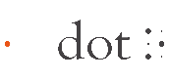
DOT INCORPORATION
401~405, 146, Gasan Digital 1-ro, Geumcheon-gu, Seoul, Republic of Korea (ZIP 08507)
Tel.: +82) 2-864-1113 Fax: +82) 2-864-1989
Email: inquiry@dotincorp.com
Homepage: https://www.dotincorp.com

 EC Representative
Grambly GmbH
Carl-Benz-Strasse 35, 60386 Frankfurt am Main, GERMANY
Tel: +49 15123651622

6. Product Certifications
Country | South Korea | USA | Europe
Cerification | KC | FCC | CE | RoHS | WEEE
Cerification | R-R-D0T-DPA320X | 2BAM7DPA320X |  | 
Cerification |  | 

Country | England | Japan | Australia
Cerification | UKCA | JAPAN MIC | RCM
Cerification |  | R 217-252498

