

Integrated User Manual
Dot Pad X
(Including the User Manual for Dot Pad X and User Guides for Using the Dot Pad with Dot Canvas, NVDA, JAWS, and VoiceOver)

08507
146, Gasan Digital 1-ro, Geumcheon-gu, Seoul, Korea
Room 403 (Daeryung Techno Town 22nd)
Phone Number: +82) 2-864-1113
Fax: +82) 2-864-1989
Email: inquiry@dotincorp.com
Homepage: www.dotincorp.com

Table of Contents

Table of Contents 2
User Manual: Dot Pad X 7
1. About Dot Pad X 7
1.1. Introduction 7
1.2. What is Dot Pad X 7
1.2.1. What’s in the Box 7
1.3. Before Using Your Dot Pad X 7
1.4. Dot Pad X Appearance 8
1.4.1. Dot Pad X Top View 8
1.4.2. Dot Pad X Right Side 8
1.4.3. Dot Pad X Left Side 8
1.4.4. Dot Pad X Bottom Surface 8
2. Basic Functions 9
2.1. Powering on the Dot Pad X 9
2.2. Powering off the Dot Pad X 9
2.3. Charging the Dot Pad X 9
2.3.1. Checking the Battery Level 9
2.4. Checking the Charging Status 10
2.4.1. Charging While Powered On 10
2.4.2. Charging While Powered Off 10
2.4.3. Charging Complete 10
3. Using Dot Pad X 11
3.1. Using Dot Pad X with Dot Canvas 11
3.2. Using Dot Pad X with Dot Book (TBD) 11
3.3. Using Dot Pad X with Voiceover 11
3.4. Using Dot Pad X with JAWS (TBD) 11
3.5. Using Dot Pad X with NVDA 11
4. Specifications 11
4.1. Hardware Specifications 11
4.2. Communication Specifications 12
5. Handling and Safety Precautions 12
6. Customer Support 16
7. Product Certification 16
User Guide: Using the Dot Pad 320 with Dot Canvas 19
8. Introduction 19
8.1. Introduction to Dot Canvas 19
8.2. System Requirements 19
9. Using Dot Canvas App 19
9.1. Introduction to Dot Canvas App 19
9.2. Starting Dot Canvas App 20
9.2.1. Downloading Dot Canvas App 20
9.2.2. Creating an Account 20
9.2.3. Logging In 20
9.2.4. Finding Forgotten Username/Password 20
9.2.5. Screen Layout of Dot Canvas App 20
9.3. Connecting Dot Canvas App with the Dot Pad 21
9.3.1. Troubleshooting Connection Issues 21
9.3.2. Disconnecting the Dot Pad 21
9.4. Using Dot Canvas App Features 22
9.4.1. Create Canvas 22
9.4.2. My Drawings 25
9.4.3. Dot Cloud 25
9.4.4. Settings 25
9.4.5. Using the Dot Pad buttons in Dot Canvas App 25
10. Using Dot Canvas Web 28
10.1. Introducing Dot Canvas Web 28
10.1.1. Screen Layout of Dot Canvas Web 28
10.2. Starting Dot Canvas Web 28
10.3. Connecting Dot Canvas Web to Dot Pad 28
10.3.1. Troubleshooting Connection Issues 29
10.3.2. Disconnecting the Dot Pad 29
10.4. Using Dot Canvas Web Features 29
10.4.1. Create Canvas 29
10.4.2. Dot Cloud 33
10.5. Updating Firmware in Dot Support Page 34
User Guide: Using the Dot Pad 320 with NVDA 35
11. Introduction 35
11.1. Overview of Using NVDA with the Dot Pad 320 35
11.2. Feature Overview 35
11.3. System Requirements 36
12. Starting Guide for Using NVDA with the Dot Pad 320 36
12.1. Installation and Setup 36
12.1.1. Installing NVDA 36
12.1.2. Installing the NVDA Dot Pad 320 Driver 36
12.2. Connecting the Dot Pad 320 to NVDA 36
12.2.1. Automatic Connection 37
12.2.2. Manual Connection 37
12.3. Learning Basic NVDA Shortcuts and Operations 37
13. Navigating NVDA with the Dot Pad 320 37
13.1. Navigating System Focus with the Dot Pad 320 38
13.2. Navigating the System Caret with the Dot Pad 320 38
13.3. Navigating the Navigator Object with the Dot Pad 320 39
13.4. Navigating NVDA Using the Dot Pad 320 Button Keys 39
14. Using NVDA with the Dual Braille Display of the Dot Pad 320 40
14.1. NVDA Navigator Object Commands 40
14.2. NVDA Review Cursor Commands 41
15. Converting Microsoft Excel Charts on the Dot Pad 320 42
16. Guidelines for Configuring Dot Pad 320 in NVDA 43
16.1. Adjusting Settings for the Dot Pad 320 in NVDA 43
16.1.1. Braille Tethering (Default Automatic) 43
16.2. Setting Up the Dot Pad 320 Button Keys 43
User Guide: Using the Dot Pad 320 with Jaws 44
17. Introduction 44
17.1. Introduction to Jaws 44
17.2. System Requirements 44
18. Overview of the Connection Process 44
18.1. Connecting your Dot Pad to JAWS 44
18.2. Connecting with a USB Cable 44
18.2.1. To connect the Dot Pad using a USB cable 44
18.2.2. Configuring JAWS for a USB Connection 44
18.3. Connecting via Bluetooth 45
19. An Overview of Using JAWS and Braille 45
19.1. The Dot Pad Displays 45
19.1.1. On the 20-cell display: 45
19.2. Navigating with the Buttons on the Dot Pad 46
19.3. Using Contracted Braille 47
20. Multi-line Braille Support 47
20.1. Wrapped mode 47
20.2. Cropped mode 47
20.3. Set Braille mode 47
21. Using Split Braille 47
21.1. Activating Split Braille 47
22. Accessing Math Content with JAWS and Dot Pad 48
22.1. Reading Math on the Web 48
22.2. Reading Math in Microsoft Word 48
User Guide: Using the Dot Pad 320 with VoiceOver 49
23. Introduction of VoiceOver & Dot Pad 320 49
23.1. Feature Overview 49
23.2. System Requirements 50
24. Using the Dot Pad 320 with iOS & iPad OS 50
24.1. Feature Overview 50
24.2. System Requirements 50
24.3. Connecting the Dot Pad 320 to VoiceOver 50
24.4. Reading Content with Single-Line Braille Display 51
24.5. Reading Content with Multi-Line Braille Display 51
24.5.1. Basic Multi-Line Braille Output Mode (Braille Text mode > Reading Mode) 51
24.5.2. Image Skipping Mode (Braille Text Mode - Reading Mode (No Images)) 52
24.5.3. Quick Screen Navigation Mode (preview mode) 52
24.5.4. Image Viewing Mode (Images) 52
24.6. Displaying Screen Images on the Dot Pad 320 52
24.6.1. Basic Image Output Setup 52
24.6.2. Zooming In/Out on images 53
24.6.3. Scrolling Through Images 53
24.6.4. Inverting Images 53
24.6.5. Reading Images on the Dot Pad 320 with VoiceOver Recognition 54
24.7. Reading Graphs 54
24.8. Dot Pad Shortcut List in iOS & iPadOS 54
24.9. Modifying Dot Pad Shortcuts 55
25. Using the Dot Pad with macOS 56
25.1. Feature Overview 56
25.2. System Requirements 56
25.3. Connecting the Dot Pad to VoiceOver 56
25.4. Reading Screens with Single-Line Braille Display 57
25.5. Displaying Screen Images on the Dot Pad 57
25.5.1. Basic Image Output Settings 57
25.5.2. Zooming In/Out on Images 57
25.5.3. Scrolling Through Images 57
25.5.4. Inverting Images 58
25.5.5. Reading Images on the Dot Pad with Voiceover Recognition 58
25.6. Dot Pad Shortcut List in macOS 58
25.7. Creating VoiceOver Shortcuts for the Dot Pad 320 59
25.8. Modifying Dot Pad Shortcuts in VoiceOver 59

User Manual: Dot Pad X

About Dot Pad X

Introduction
Welcome to the Dot Family! We are delighted that you have chosen Dot Pad X. Dot Pad X is designed to provide rich tactile graphics and multi-line braille experience, enhancing the accessibility of visual information and boosting productivity for visually impaired users. Dot Pad X represents a significant advancement in assistive technology, bringing tactile graphics and braille text together in one innovative device.

What is Dot Pad X
Dot Pad X is a tactile information display capable of representing both braille text and tactile graphics simultaneously. This functionality allows users to access a wide range of visual content in a tactile format, making it easier to understand and interact with complex information. Additionally, with its multi-line braille, users can experience multiple lines of braille on a single screen, engaging with detailed content more effectively.
As a tactile display, Dot Pad X is compatible with screen readers such as JAWS, NVDA and Voiceover. Additionally, it must be connected to software services developed by Dot or third-party developers using Dot's SDK, allowing for versatile usage across various platforms and applications.

What’s in the Box
When you purchase a Dot Pad X, it includes the following components:
- Dot Pad X: 1unit
- Dot Pad X Pouch: 1 pc
- Dot Pad bumper case: 1pc
- C to C Cable: 1pcs
- 300-cell Protection Cell Protector: 3 pcs
- 20-cell Protection Cell protector: 3 pcs
- Screwdriver for protection cell protector replacement: 1 piece
- Extra Screws: 10pcs
- User Manual and Warranty Card: 1 set

Before Using Your Dot Pad X
- Please fully charge Dot Pad X before first use. We recommend charging for at least 2 hours using the included USB-C cable and a certified power adapter that meets the rated specifications (5V, 3A).
- When fully charged, Dot Pad X can typically be used for 8 hours or more. Actual battery life may vary depending on usage patterns and environmental conditions.
- When the battery level reaches Level 5 (approximately 90% or higher), the charging speed slows to prevent overcharging and prolong battery life. It may take up to 2 hours to reach full charge from Level 5, but you can safely disconnect the charger and use your Dot Pad X even if the charging message isn’t displayed.
- Dot Pad X must be connected to a host Your Dot Pad X via Bluetooth or a USB cable. When both Bluetooth and USB are connected at the same time, USB takes priority.

Dot Pad X Appearance
When you take the Dot Pad X out of the box and place it on a desk, your Dot Pad X is correctly positioned when the main body is slightly inclined downward toward you.

Dot Pad X Top View
When the Dot Pad X is properly oriented, the top surface consists of the following components, arranged from closest to farthest from the user:
- Text Display Area: This area consists of 20 braille cells arranged in a horizontal rectangular frame. Each cell follows the standard braille spacing, allowing for the simultaneous display of up to 20 braille characters.
- Control buttons Area: From left to right, the control buttons area includes the Previous Panning Key, Function Keys (F1, F2, F3, F4), and the Next Panning Key.
- Tactile indicators are provided on the F1 and F4 keys to distinguish them from the others. The panning keys are triangular in shape, making them easily distinguishable from the oval-shaped function keys.
※ The panning keys are used to navigate to the previous or next line, based on the 20-cell braille text area.
- LED Status Indicator: Located at the far right of the control buttons area, the LED status light communicates Your Dot Pad X status such as power, Bluetooth connection, and charging via color and blinking patterns.
- Graphic Display Area: This is the largest area on the front of the Dot Pad X, consisting of 300 8-dot braille cells (30 columns × 10 rows).
The cells in this area are more densely packed than those in the text area, with evenly spaced pins in all directions, enabling precise tactile rendering of graphical content.
It can display real-time screen content from iPhones or iPads, as well as tactile graphics from dedicated applications compatible with the Dot Pad X.

Dot Pad X Right Side
On the right side of the Dot Pad X, you’ll find a USB-C port labeled with the braille character for the letter “p.” This port is dedicated solely to charging the device and does not support data transfer. Beneath the USB-C port is the power switch. To turn on your Dot Pad X, slide the switch forward away from you, you’ll feel a long vibration as confirmation. To turn it off, slide the switch backward toward you.

Dot Pad X Left Side
The Dot Pad X’s left side has a USB-C port labeled “d.” In Braille (dots 1, 4, and 5), it connects to screen readers and apps or performs firmware updates with Dot Canvas.
※ Please note: This port does not support charging. To charge your Dot Pad X, always use the USB-C port on the right side.

Dot Pad X Bottom Surface
On the bottom side of the Dot Pad X, you will find the battery compartment and screws that allow access to the protective film covering the braille cells. The built-in battery is not user replaceable. If replacement is necessary, it must be performed by Dot Inc. or an authorized service provider.
The protective film on the braille cell surface can be replaced by removing the screws located on the bottom of your Dot Pad X.
For more information or assistance regarding the protective film, please contact Dot Inc. customer support.

Basic Functions
This section introduces the basic functions and notifications of the Dot Pad X.

Powering on the Dot Pad X
To turn on the Dot Pad X, slide the power switch forward away from you—located at the midway along on the right edge of your Dot Pad X. Your Dot Pad X will emit a long vibration, indicating that it is powering on.
Upon startup, the Dot logo will appear on the 300-cell graphic display. Approximately 4 seconds later, a 4-character Bluetooth ID—consisting of uppercase letters and numbers—will be shown in tactile Latin print format.
The same 4-character ID is also displayed in English Grade 1 Braille on the 20-cell text display, preceded by the prefix "le", which stands for Low Energy Bluetooth mode. This indicates that your Dot Pad X is ready to wirelessly connect to an iOS device or computer.
This 4-character ID is unique to each unit, so please confirm the code when connecting your Dot Pad X to a PC or IOS device to ensure proper pairing.
Once powered on, the LED indicator located at the bottom right corner of your Dot Pad X will blink blue, signaling that the Dot Pad is searching for a host device. When a connection is successfully established, the LED will stay solid blue (no longer blinking).

Powering off the Dot Pad X
To turn off the Dot Pad X, slide the power switch backward toward you. All braille pins will retract and reset, indicating that your Dot Pad X has shut down properly. When turning your Dot Pad X back on, please wait at least 3 seconds after powering it off. If the power is turned back on immediately, the pins may not have fully retracted, and the previous braille display may remain visible. To ensure proper initialization, always wait a few seconds before restarting your Dot Pad X.

Charging the Dot Pad X
Always use the USB-C port located on the right side of your Dot Pad X. We recommend using the included USB-C cable and a certified power adapter that supports QC 3.0 and provides an output of DC 5V / 3A.
For optimal performance, it is best to use your Dot Pad X when the battery is fully charged. If the battery level is low, please ensure your Dot Pad X is sufficiently charged before use.
You can check the current battery level using the method described in the section below.

Checking the Battery Level
To check the battery level of the Dot Pad X, make sure your Dot Pad X is powered on.
Then, press and hold both the Previous and Next Panning Keys simultaneously for at least 1.5 seconds, and release.
The battery level is divided into five levels and can be checked through vibration and tactile feedback.
- When Bluetooth is not connected, the battery level is displayed on the 20-cell text display as tactile output for 7 seconds, along with vibration feedback.
- When Bluetooth is connected, only vibration feedback is provided, and no information is shown on the 20-cell display.
The battery level is divided into five levels, and each level is indicated by the number of vibrations.
The number of vibrations corresponds to the battery level: 5 for Level 5, 4 for Level 4, and so on down to 1 for Level 1.
Number of Vibrations | 5 | 4 | 3 | 2 | 1
Battery Level | Level 5 | Level 4 | Level 3 | Level 2 | Level 1
In addition to vibration feedback, the battery level is also displayed tactilely on the 20-cell text display.
The battery level is divided into five levels (Level 1 to Level 5), and the cells are filled sequentially according to the current battery level.
Tactile Feedback | 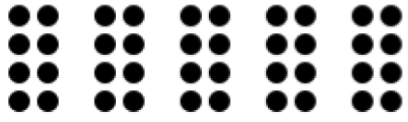 | 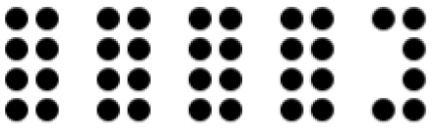 | 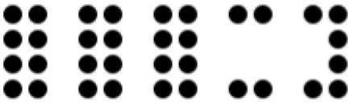 | 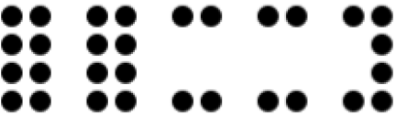 | 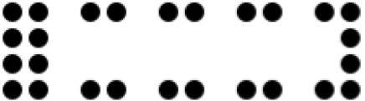
Battery Level | Level 5 | Level 4 | Level 3 | Level 2 | Level 1
If your Dot Pad X is used extensively while the battery is at Level 1, it may become completely discharged and shut down unexpectedly.
If your Dot Pad X vibrates twice every 5 minutes, it indicates that the battery level is low, and it needs to be charged. When this feedback occurs, please charge fully up to Level 5 before further use. Charging from this low-battery state to Level 5 typically takes approximately 2 hours and 30 minutes.

Checking the Charging Status

Charging While Powered On
When Dot Pad X is powered on but not connected to a host device via Bluetooth, your Dot Pad X provides multiple indicators during charging. A red LED light turns on at the bottom right corner of your Dot Pad X to indicate that charging is in progress. At the same time, vibration feedback is provided to show the current battery level. Additionally, the 20-cell text display presents tactile output that corresponds to the battery level, allowing users to confirm charging status through touch.
When Dot Pad X is powered on and connected to a host device via Bluetooth, charging is indicated by a red LED light at the bottom right corner of your Dot Pad X, along with vibration feedback that reflects the current battery level. In this state, tactile feedback on the 20-cell text display is not shown, to avoid disrupting the user experience during Bluetooth communication.

Charging While Powered Off
When your Dot Pad X is powered off, no vibration feedback is provided to indicate the battery level. However, the red LED indicator at the bottom right corner will light up, allowing users to confirm that charging is in progress.

Charging Complete
If Dot Pad X is switched on while charging, you will know when the battery is full when the red LED indicator turns off and you feel two vibrations.
If Dot Pad X is switched off while charging, the red LED still turns off when fully charged, but you will not receive any vibration alerts.

Using Dot Pad X
Dot Pad X is a braille display that must be connected to other devices such as laptop, iPad, or iPhone. It offers new experience in using braille and tactile graphics through software developed based on the Dot Pad SDK, along with screen readers like JAWS, NVDA and Voiceover, providing multi-line and tactile graphic braille Your Dot Pad X experience.

Using Dot Pad X with Dot Canvas
Dot Canvas is a versatile digital tool for the Dot Pad X developed by Dot Inc., available as both an app and a web-based platform. It allows users to create, edit, save, and share tactile graphics and braille text. Tailored for visually impaired and blind users, Dot Canvas facilitates the creation of rich, multi-sensory content, enhancing learning, creativity, and accessibility. For comprehensive usage instructions, please refer to the most recent ‘Using the Dot Pad X with Dot Canvas’ manual.
Download link: Using Dot Pad X with Dot Canvas
Link to Dot Canvas Web: https://apps-dotincorp.com/
Link to download Dot Canvas App: https://apps.apple.com/kr/app/dot-canvas/id1613110785

Using Dot Pad X with Dot Book (TBD)

Using Dot Pad X with Voiceover
Voiceover is Apple’s advanced screen reader designed to assist users with visual impairments by providing both audio and tactile feedback. When used with Dot Pad X, Voiceover delivers tactile output for both text and graphics, offering a comprehensive and intuitive accessibility solution.
This combination significantly enhances interaction between your Dot Pad X and the user.
For detailed instructions, please refer to the latest guide titled “Using Dot Pad X with Voiceover.”.
Download link: Using Dot Pad X with VoiceOver

Using Dot Pad X with JAWS (TBD)

Using Dot Pad X with NVDA
NVDA (Non Visual Desktop Access) is a free and open-source screen reader developed by NV Access for Microsoft Windows. Dot Inc. provides a dedicated NVDA driver to ensure seamless compatibility with Dot Pad X, enhancing the tactile graphic display experience for users. For detailed instructions on how to effectively use Dot Pad X with NVDA, please refer to the latest guide titled “Using Dot Pad X with NVDA.”
Download link: Using Dot Pad X with NVDA

Specifications

Hardware Specifications
Tactile Display: 300 cells
Braille Display: 20 cells
Cell Protection: Separate covers for 300-cell (graphics) and 20-cell (text) areas
Processor: ARM Cortex-M4, 32-bit, 120MHz
RAM: 64KB
Flash Memory: 128KB.
External Memory: Not supported.
Wireless: Bluetooth LE 5.0
Sensor / Camera: None
Dimensions & Weight
Size: 273.5(W) × 228.5(D) × 31.0(H) mm
Weight: Approx. 1,200g ±10%
Function Keys: 4
Panning Keys: Left, Right
Power Switch: 1
Left USB-C: Data & firmware updates.
Right USB-C: Power & charging
Battery: Li-ion 3.60V, 10.05Ah, 36.18Wh (1S3P)
Charging: DC 5V / min. 3A
Fast Charging: QC and PD supported.
Operating Temp: 0°C ~ 35°C
Storage Temp (Short): -20°C ~ 45°C
Storage Temp (Long): -20°C ~ 25°C
Recovery Time (min temp): 24 hours
Operating Humidity: 20% ~ 75% R.H.
Storage Humidity: 10% ~ 80% R.H.
Operating Pressure: 500 ~ 1060 hPa

Communication Specifications
Specification: Bluetooth 5.0 (LE, up to 10 kbps)
Output Power: 0 dBm.
Data Rate: 10 kbps
Protocols: GAP, GATT, SM, L2CAP, Integrated public profile protectors
Sensitivity: -90 dBm
Frequency Band: 2.402 GHz – 2.480 GHz

Handling and Safety Precautions
The contents of this manual may differ from the actual product, depending on the software version of the product, the specifications of the model, and the user's settings. Only use Dot Pad X for the intended purposes as described in this user guide. Use with caution as the product may be damaged if impacted.
- Keep the Dot Pad X dry. If used in a humid place or becomes wet, the product may not work properly.
- The Dot Pad X has a built-in magnet. Do not place it close to other magnetic products or metals. There is a risk of damage to the product.
- Use the Dot Pad X on a table away from the body and when used in a dusty area, foreign objects may get inside and interfere with your Dot Pad X’s operation.
- Only use accessories provided by Dot Inc. Use of other third-party accessories may cause the product to malfunction and may result in the user not receiving the warranty services provided by Dot Inc.
- Dot Pad X has passed the EMC (Electromagnetic Compatibility) test. Situational or environmental variables may still cause interference or affect signals via surrounding products. Heat generation and malfunction issues may occur.
- Dot Pad X’s wireless conducting power follows the RF (Radio Frequency) standard. However, if the voltage and temperature are not within the standard range, the product's wireless conducting power may be unstable and could impact the performance.
- Dot Pad X has passed the RSE (Radiated Spurious Emission) test. However, if Dot Pad X is used with non-component accessories, it may cause malfunction.
- Dot Pad X’s Short Range Wireless Communication function satisfies the data transfer security standards. However, if the software or firmware is modified or changed without authorization, the product’s data transfer security may operate abnormally.
- Dot Pad X has passed all the qualification tests mentioned above by qualified laboratories. However, if the product is placed in different conditions that could cause functional errors or is applied to atypical operation methods, the product may operate abnormally. It is advised to turn off your Dot Pad X, disconnect the power, stop using your Dot Pad X, and contact customer service.
- If pressure is applied while the braille cells are moving, the product may not function normally. In this case, it is not a breakdown, so we suggest you remove your hand and try to print the desired image again.
- If the product is used in the opposite direction, it may not be able to represent the image or braille correctly.
- Some product specifications are subject to change without notice to better serve you.
- If Dot Pad X’s firmware provided by Dot Inc. is changed or applied to the product through an unofficial channel, it may cause damage to the product or cause errors. In this case, the warranty service is voided.
- Since Dot Pad X has the possibility of radio interference during use, it cannot perform services related to human safety.
- When charging Dot Pad X, the product temperature may rise, and if the temperature of the battery rises above a certain level, the charge may be automatically stopped for safety reasons.

Use safety in the following situations:
1. Do not use Dot Pad X in a severe lightning storm.
During severe lightning and thunder, refrain from using the product and disconnect the charger from the power source. Continuing its use can cause injury, fire, or malfunction.
2. Do not use Dot Pad X in prohibited areas.
Do not use Dot Pad X in areas where use of the product is prohibited, such as in airplanes or hospitals. Electronics and communication products can be affected by electromagnetic waves.
3. Never disassemble and modify.
Do not disassemble or shock the product. There is a risk of electric shock, short circuit, or fire. Warranty services do not cover disassembly of the product. If your Dot Pad X needs service, contact customer service at your local distributor or contact Dot Inc. Do not use it in a damaged or broken state as it may cause fires, burns, and electric shock. In this case, please stop using the product and contact customer service.
4. Use only the correct power cable and an appropriate power outlet.
Please connect and use the USB cable correctly to avoid the charging cable from loosening. Do not bend, pull, heat, cut, or loosen the cables as it may cause fire or electric shock. When not in use, disconnect the charger's cable. There may be a risk of electric shock if your Dot Pad X is used while charging. When removing the adapter, hold the adapter and remove it. If you remove the adapter by pulling the cable, a disconnection within the cable may cause charging failure.
5. Avoid high temperatures and humid environments.
Do not use the product in a hot and humid place. If the product gets wet, turn it off and dry it thoroughly before reusing. Do not place it on duvets, carpets, household electric appliances, or in direct sunlight (such as car seats) for extended periods. The exterior may become deformed, broken, or explode. If the temperature of the product sharply rises, stop using the product and contact customer service.
*Operating Temperature: 0℃ ~ +50℃, Storage Temperature: -20℃ ~ +60℃
6. Do not use any chemicals.
Never use chemicals such as alcohol or benzene to clean Dot Pad X. This may start a fire. If any foreign objects get on the product or charger, wipe it with a soft cloth.
7. Avoid metal and magnetism.
Do not keep the charging ports close to any metal such as necklaces, keys, coins, nails, watches, etc. If a metal object is short circuited with the charging port, there is a risk of explosion. Do not store your Dot Pad X near magnetic fields. Magnetic fields can impact your Dot Pad X. It may cause a malfunction from exposure to magnetic fields.
8. Use special caution for children and pets
Store products, chargers, parts, etc. out of reach of children or pets. If the product, charger, or parts gets in your mouth or damaged by impact, you may be at risk of electric shock or exposure to electromagnetic waves. Be careful not to allow children or pets to swallow products, chargers, parts, etc. There is a risk of suffocation, explosion, and fire.
9.Do not use in an explosive atmosphere.
Do not use the product in explosive areas. This may affect high frequency your Dot Pad X. Do not place the product on an unstable surface, such as on a shaky or sloping area. your Dot Pad X’s fall may cause injury or damage to the product.
10. Be aware of fire risks.
Do not cover or wrap Dot Pad X with fabric materials such as a blanket during use or when charging. Do not dispose of Dot Pad X with general waste. It can cause fires, explosions, and environmental pollution.
11. Avoid excessive contact under heated conditions.
Avoid using the product when the temperature on the surface of the product rises above the appropriate level. If you come into contact with the product in this state for a long time, there is a risk of burns or disturbing cell protector pigmentation. If the external protective cover comes off or you experience an allergic reaction to the material of the product, stop using the product immediately and consult a physician.
12. Keep Dot Pad X in a safe place for storage.
When not in use for a long time, disconnect the charger from Dot Pad X and store it in a safe place. When storing the charger, be careful not to severely fold or twist the USB cable. If the USB cable is stored or used with an excessive fold or twist, the silicone coating of the cable can be stripped off or the cable may break and cause a failure or accident.
13. Be careful in handling the battery.
In hot and humid places, the battery may not charge well or may drain quickly. Do not expose it to direct sunlight or use your Dot Pad X in a humid place, such as a bathroom.
- If you want to use Dot Pad X after a long period of unuse, please use it again after fully charging.
- Please note that it may explode if the battery is forcibly removed.
- Do not change, modify, or expose the Dot Pad X to liquids. Once your Dot Pad X is fully charged, disconnect the charger from the outlet and your Dot Pad X to avoid unnecessary power consumption.
- Please bring your product and charger with you when you visit a service center due to battery problems.
- If the product gets heated while charging, please wear gloves or use a tool other than your body to separate the charger and Dot Pad X.
- Overheating may cause damage to the product. If your Dot Pad X overheats while charging, please unplug the USB charging cable and contact a Dot Inc. licensed service center.
14. Do not give any shock or impact.
If you apply strong force to your Dot Pad X, place heavy objects on top, etc., it may cause an impact to the product. This may damage your Dot Pad X, cause malfunction, or shorten its lifespan. This may also cause overheating, combustion, or fire. When not in use, store it in a safe place to avoid shock and damage to your Dot Pad X.
15. Do not use chargers that have not been certified.
Avoid using uncertified chargers as it may lead to damage of the battery causing injury to the user or your Dot Pad X.

Customer Support
For any inquiries, support, or additional information, you can contact Dot Inc. at the following:
Dot Email: inquiry@dotincorp.com
Dot Phone Number: +82) 2-864-1113
Dot Homepage: https://www.dotincorp.com/

Product Certification
South Korea: KC (KC ID: R-R-DOT-DPA320X)
United States: FCC (FCC ID: 2BAM7DPA320X)
Europe: CE
United Kingdom: UKCA
Japan: Japan MIC (ID: 217-252498)
Australia: RCM
1. KC: Korea Certification
※ The wireless equipment in use may cause radio interference.
※ The manufacturer and installer cannot provide services related to human safety as the wireless equipment may cause radio interference.
2. FCC: Federal Communications Commission

FCC Class A
This equipment has been tested and found to comply with the limits for a Class A digital Your Dot Pad X, pursuant to Part 15 of the FCC Rules. These limits are designed to provide reasonable protection against harmful interference when the equipment is operated in a commercial environment. This equipment generates, uses, and can radiate radio frequency energy and, if not installed and used in accordance with the instruction manual, may cause harmful interference to radio communications. Operation of this equipment in a residential area is likely to cause harmful interference in which case the user will be required to correct the interference at his own expense.
FCC Class B
This equipment has been tested and found to comply with the limits for a Class B digital Your Dot Pad X, pursuant to Part 15 of the FCC Rules. These limits are designed to provide reasonable protection against harmful interference in a residential installation. This equipment generates, uses, and can radiate radio frequency energy and, if not installed and used in accordance with the instructions, may cause harmful interference to radio or television reception, which can be determined by turning the equipment off and back on, the user is encouraged to try to correct the interference by one or more of the following measures:
- Reorient or relocate the receiving antenna.
- Increase the separation between the equipment and receiver.
- Connect the equipment into an outlet in a circuit different from that to which the receiver is connected.
- Consult the dealer or an experienced radio/TV technician for help.
Caution
The manufacturer is not responsible for any radio or TV interference caused by unauthorized changes or modifications to this equipment. Such changes or modifications could avoid the user's authority to operate the equipment.
This equipment must be installed and operated in accordance with the instructions provided and the antenna(s) used for this transmitter must be installed to provide a separation distance of at least 20 cm from all persons and must not be co-located or operating in conjunction with any other antenna or transmitter.
All rights reserved. This manual may not be reproduced in any form. Even in part, or duplicated or processed using electronic, mechanical, or chemical processes without the written permission of the publisher. This booklet may contain errors or misprints. The information it contains is regularly checked and corrections are included in subsequent editions. We disclaim any responsibility for any technical error or printing error, or their consequences. All trademarks’ patents are recognized.
3. CE: European Conformity

“CE” mark indicates that this product complies with the European requirements for safety, health, environment, and customer protection. “CE” mark devices are intended for sales in Europe.
4. WEEE: Waste from Electrical and Electronic Equipment
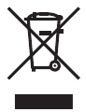
This symbol [crossed-out wheeled bin WEEE Annex Ⅳ] indicates separate collection of waste electrical and electronic equipment in the EU countries. Please do not throw the equipment into the domestic refuse. Please use the return and collection systems available in your country for proper disposal of this product.

Disclaimer
No warranty or representation, either expressed or implied, is made with respect to the contents of this documentation, its quality, performance, merchantability, or fitness for a particular purpose. The information presented in this documentation has been carefully checked for reliability; however, no responsibility is assumed for inaccuracies. The information contained in this documentation is subject to change without notice.
In no event will Dot Inc. be liable for direct, indirect, special, incidental, or consequential damages arising out of the use or inability to use this product or documentation, even when advised of the possibility of such damages.
[FCC and CE Compliance Statement]
These limits are designed to provide reasonable protection against frequency interference in residential installation. This equipment generates uses and can radiate radio frequency energy, and if not installed or used in accordance with the instructions, may cause harmful interference to radio communication. However, there is no guarantee that interference will not occur in television reception, which can be determined by turning the equipment off and on.
The user is encouraged to try and correct the interference by one or more of the following measures:
- Reorient or relocate the receiving antenna.
- Increase the separation between the equipment and the receiver.
- Connect the equipment into an outlet on a circuit different from that to which the receiver is connected to.

User Guide: Using the Dot Pad 320 with Dot Canvas

Introduction

Introduction to Dot Canvas
Dot Canvas is a versatile digital tool designed for the Dot Pad, offering both an app and a web-based platform to create, edit, save, and share tactile graphics and braille text. Tailored to the needs of visually impaired and blind users, Dot Canvas enables the creation of rich, multi-sensory content, empowering users to design and interact with tactile information in ways that enhance learning, creativity, and accessibility.
It provides a comprehensive solution for creating and managing tactile content, making it an essential tool for users seeking to leverage the full capabilities of the Dot Pad in various contexts, from education and professional use to personal projects.

System Requirements
Dot Canvas APP
- Operating Systems: iOS/iPadOS
- Download: Available on the Apple app store by searching for ‘Dot Canvas.’
※ For Optimal drawing experience, using the app with an iPad is recommended.
Dot Canvas Web
- Hardware Requirements: PC with Bluetooth support
※ Dot Canvas Web is optimized for use with the Chrome browser

Using Dot Canvas App

Introduction to Dot Canvas App
Dot Canvas App is an iPhone/ iPad application that can be used in connection with the Dot Pad, enabling users to create and display tactile information such as dots, lines, shapes, images, and text.
It empowers visually impaired and blind users to design and modify their own tactile graphic content. Users can simply save the content to “My Drawing,” “Personal Drive,” or share them on the “Public Drive.” The tactile graphics, whether saved or shared, can be easily accessed and displayed on the connected Dot Pad.

Starting Dot Canvas App

Downloading Dot Canvas App
Search for “Dot Canvas” in the Apple App Store and download it.
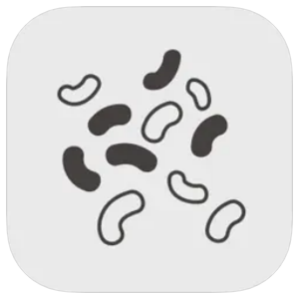 Dot Canvas App
※ Dot Canvas App is an application developed by Dot Incorporation

Creating an Account
Dot Canvas is provided as an app and a website. Users can create one account to access both versions and experience the same tactile graphic content saved in their Personal Drive. Account registration is available through both the app and the website. Account registration method through the Dot Canvas App is as follows:
- After launching Dot Canvas App, select the [Create Account] button.
- When the “Create A New Account” page comes up, fill in the required information.
- Enter the verification code issued through the email you entered.
- Complete account registration after entering the required additional information.

Logging In
After completing the account registration, you can log in to Dot Canvas App by entering your registered username and password.
- When Dot Canvas App is launched, the login screen appears, and the username input window is focused.
- Enter your username and password you created and select the Login button to move to the main screen.
※ If you enter your username and password and select the Remember ID button, the entered username information is maintained when you log in again.

Finding Forgotten Username/Password
In case you lose your username or password, you can reset your password in the following steps:
- If you lose your username, select the [Forgot Username?] button and enter the name and registered email address.
- If you lose your password, select the [Forgot Password?] button and enter your username.
- Check the verification code sent to the registered email and enter it.
- Check the username or reset your password with a new one.

Screen Layout of Dot Canvas App
The main screen of Dot Canvas App consists of the following sections:
- Create Canvas
- Create and edit the tactile graphic content using various drawing tools.
- As you draw on Dot Canvas App, the content is automatically displayed in real-time on the Dot Pad.
- My Drawing
- Save the content you create directly onto your device.
- Content saved in “My Drawing” can be printed on the Dot Pad without requiring an internet connection.
- Dot Cloud
- Dot Cloud is a cloud storage service where you can save and access your content in an Internet-connected environment.
- You can save the content you create in your Personal Drive or share them in the Public Drive.
- Settings
- Connect or disconnect from the Dot Pad.
- Select the braille language to be displayed on 20 cells of the Dot Pad
- Profile
- View the user's registered name and username.
- Log out of Dot Canvas App.

Connecting Dot Canvas App with the Dot Pad
After logging in to Dot Canvas App, it will be directed to the main screen. Users can connect Dot Canvas App to the Dot Pad via Bluetooth. To connect the Dot Pad, please follow the steps below:
- From the main screen, go to [Setting] > [Connect]
- Select the Dot Pad Bluetooth number you wish to connect to.
- When the connection is successful, the Dot Pad will vibrate twice.

Troubleshooting Connection Issues
If the Dot Pad you wish to connect to does not appear in the connection list, please check 3 things below:

- Make sure the Dot Pad is turned on.
: If the Dot Pad is turned off, turn it on and select the [Refresh] button in the connection list.
- Make sure the device’s Bluetooth running Dot Canva App is turned on.
: If the device’s Bluetooth is turned off, please turn it on and select the [Refresh] button in the connection list.
- Check whether VoiceOver is paired with the Dot Pad.
: If the Dot Pad is paired with VoiceOver braille display, please disconnect the Dot Pad with VoiceOver braille display in the following order.
- Apple [Settings] > [Accessibility] > [VoiceOver] > [Braille]
※ You can go to [Settings] > [Accessibility] > [VoiceOver] by selecting the Apple Settings button in the pop-up window.
- Focus the connected Dot Pad at the bottom of the screen and swipe up to go to More Information.
- Select [Forget this Device] to disconnect the Dot Pad.

Disconnecting the Dot Pad
To disconnect the currently connected Dot Pad, please follow the steps below:
- From the main screen of Dot Canvas APP, navigate to [Setting]
- Select the [Connect] button.
- The disconnection will be confirmed by the Dot Pad vibrating twice.

Using Dot Canvas App Features

Create Canvas
Using various drawing tools, users can freely create pictures by drawing shapes and add textual descriptions for the picture. The graphics created through Dot Canvas App are displayed on the 300-cell part of the Dot Pad in the form of tactile graphics, and the text descriptions are displayed in braille on the 20-cell part of the Dot Pad.

The layout of the Create Canvas screen is as follows:
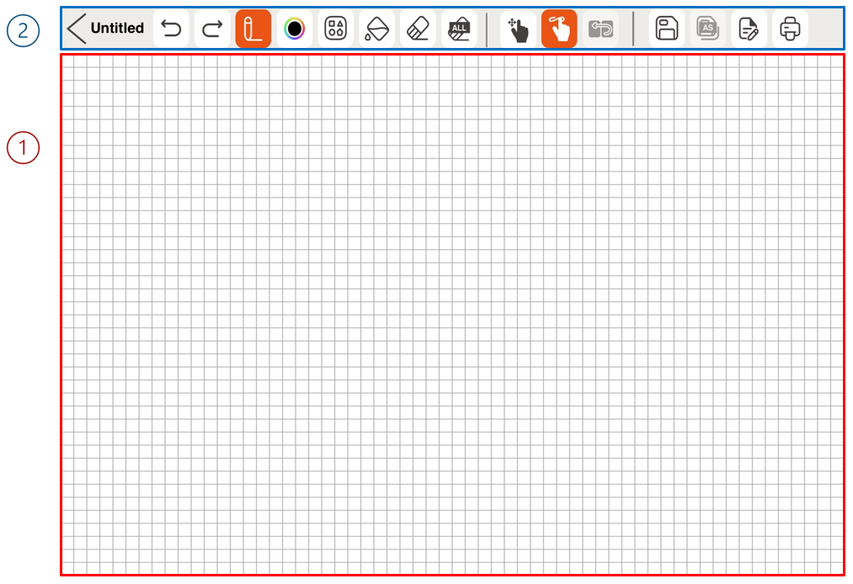

- Canvas: Occupying the largest area of the screen, the canvas is where users can draw tactile content by touch.
- Drawing Menu Bar: Located at the top of the screen, it is a collection of various drawing tools that can be used for creating and modifying tactile content.

Table 1 Dot Canvas App Drawing Tools
 | Back  Exit the Canvas Creation screen and return to the main screen.  If you press the Back button while creating tactile graphics, a warning window will prompt you to save your progress. Choosing [No] closes the window, while selecting [Save] allows you to name the file and choose a save location. The file will be saved in either My Drawings or Dot Drive, based on your selection. |  | File Name  File name on which you are working.
 | Undo/Redo  Undo or redo the latest work. | 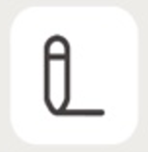 | Pen  Draw freely, just as you draw with a pen.
 | Low Vison Pen mode  Select a pen color that best suits your vision needs. There are four colors: Black, Blue, Yellow, Red | 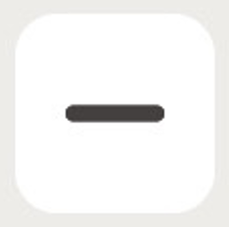 | Line  Select and adjust th.3e desired length with one finger on the screen to draw a line.
 | Square/Rectangle  Select and adjust the desired size with one finger on the screen to draw a square or rectangle. |  | Circle  Select and adjust the desired size with one finger on the screen to draw a circle.
 | Triangle  Select and adjust the desired size with one finger on the screen to draw a right triangle |  | Fill  Fill an area made up of lines to be blacked out with dots.
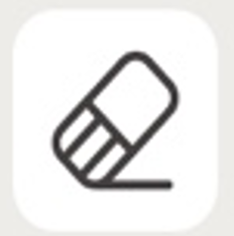 | Erase  Erase the area you want to clear. |  | Clear All  Erase all the paintings on the canvas at once.
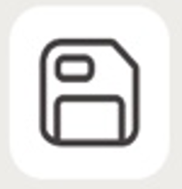 | Save  Save your work by pressing the Save button, which opens a pop-up to choose a storage location. The file will be saved in My Drawings or Dot Drive after you select the location and enter a file name. | 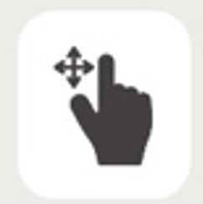 | Canvas Navigation Mode  This mode allows users to explore the position of their fingers on the screen before starting to draw.
 | Drawing Mode  This mode allows users to draw on the canvas. | 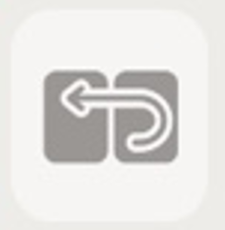 | Menu Navigation Mode  This mode is used to navigate and select drawing tools in the Dot Canvas app. (While VoiceOver is enabled)
 | Save As  If you modify an existing saved file, you can change the file name and save it. |  | Pages  • Displays a pop-up where you can create or delete a page and add a page description.  • The bottom of the pop-up shows arrow buttons and current page details for navigation.  • When inserting page description, it is automatically saved and translated into 20-cell display of the Dot Pad after the pop-up is closed.
 | Print  Print the picture you worked on to Dot Pad.

- Zoom In & Out

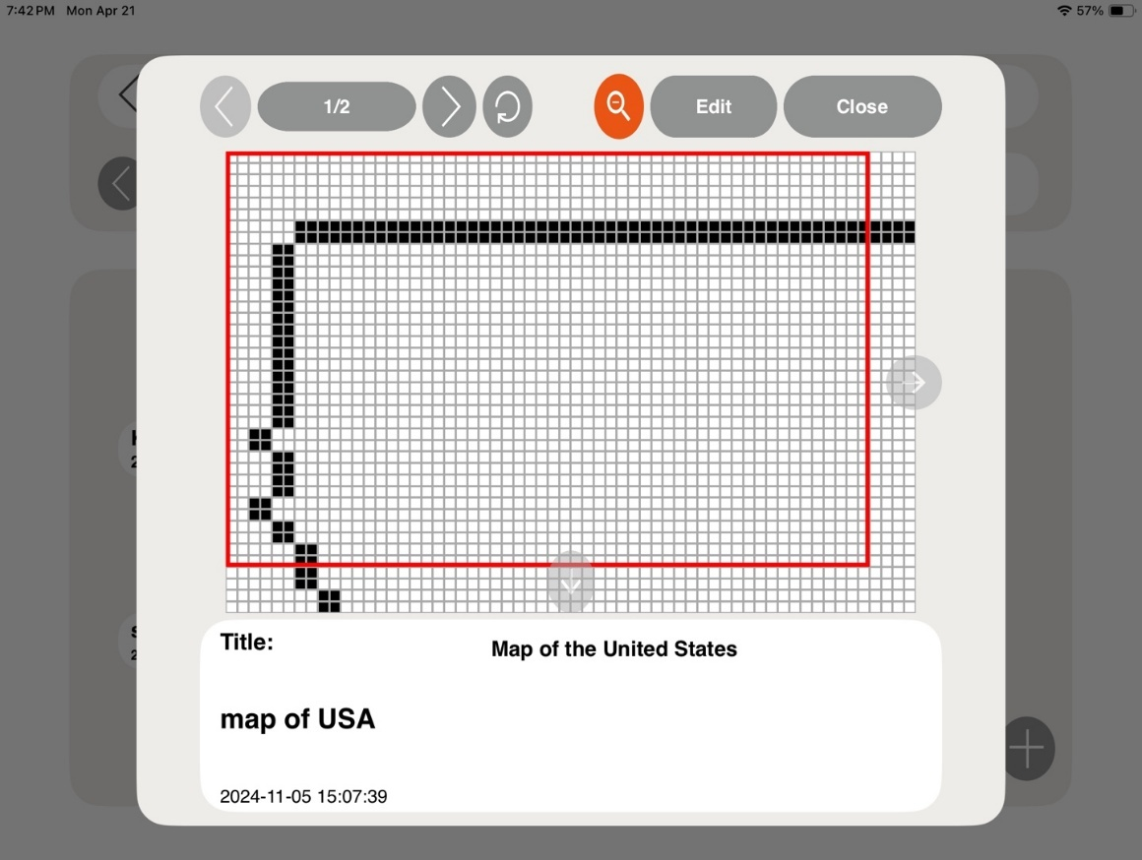

- Zoom In & Out offers a zoomed-in view of a specific area.
- To zoom in on a file, tap the magnifying glass icon at the top of the pop-up window. A red indicator box will appear over the content.
- Use the F1 and F4 keys of Dot Pad to move the box left and right, or up and down.
- Press F2 and F3 together to switch the movement direction between horizontal and vertical.

My Drawings
Dot Canvas App enables users to create or modify tactile graphic content and save it to their device’s internal storage. In the "My Drawing" section, users can view a list of files stored internally. If many files are saved, the search bar allows users to quickly find specific files by entering the file name. Each file contains the file name and the date it was created.

When selecting the file name, a context menu is displayed, and the first picture of the file is displayed on the Dot Pad. The components of the context menu are as follows:
- Open: Run the selected file. When the file runs, the picture on the first page and the description of the picture are displayed on the Dot Pad. Users can go to the previous/next page and modify the picture and description by clicking the [Edit] button.
- Delete: Deletes the selected file.
- Rename: Modify the saved file name.
- Exit: Exit the context menu.

Dot Cloud
Users can save their personal content and open various public content through Dot cloud, a cloud-based tactile graphic content online storage service provided by Dot Inc.

- Personal Drive
  - Users can upload tactile graphic content created in Dot Canvas App to their Personal Drive. This cloud-based personal storage allows access to content across multiple devices without restrictions.
- Public Drive
  - Users can explore various shared tactile graphic content organized by themes and share their own drawings with the Public Drive for others to access.

Settings
Set up the Dot Pad connection or select a braille language supported by Dot Canvas App
- Connect or Disconnect Dot Canvas App with the Dot Pad
- Select the braille language.
- Select the braille language to be displayed on the 20-cell display of the Dot Pad.
- Braille language must be in correspondence with input language.
- The 23 braille languages currently supported by Dot Canvas App are as follows:
Korean, English, Chinese, Japanese, Vietnamese, Thai, Arabic, French, Italian, Spanish, Catalan, German, Czech, Polish, Norwegian, Russian, Portuguese, Danish, Greek, Swedish, Finnish, Kazakh, Khmer.

Using the Dot Pad buttons in Dot Canvas App

- Navigating the 20-cell text display on the Dot Pad
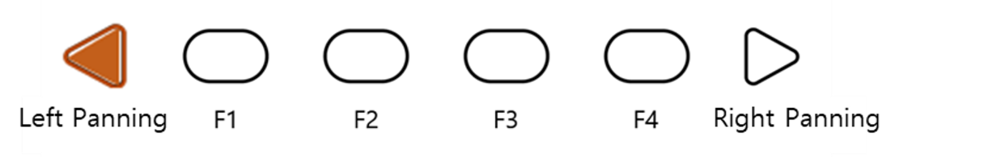
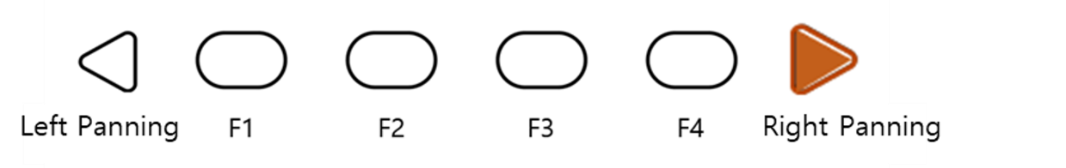
- If the content in the 20-cell text area becomes lengthy, users can navigate through the content using the panning key buttons.
- Right panning key button: Move to the next line (20 cells)
- Left panning key button: Move to the previous line (20 cells)

- Navigating the 300-cell graphic and multi-line display on the Dot Pad
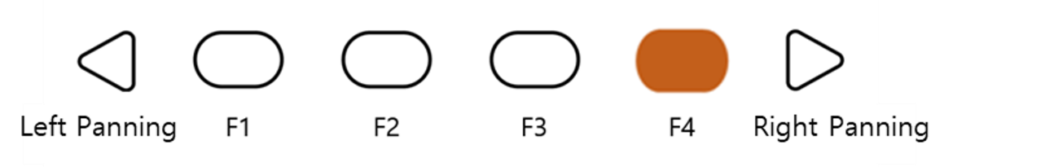
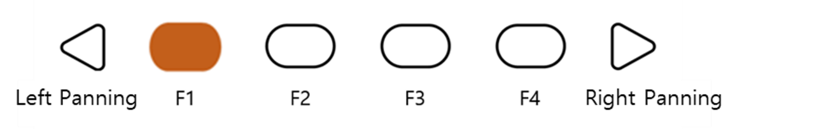
- If the content in the 300-cell graphic/multiline area becomes lengthy, users can navigate through the content using the F1 and F4 buttons.
- F4 button: Move to the next page (300 cells)
- F1 button: Move to the previous page (300 cells)

- Dot Pad Shortcut buttons for drawing tools
When connecting the Dot Pad to the Dot Canvas app, users can easily use various functions by using the Dot Pad buttons.

- Select Pen Tool
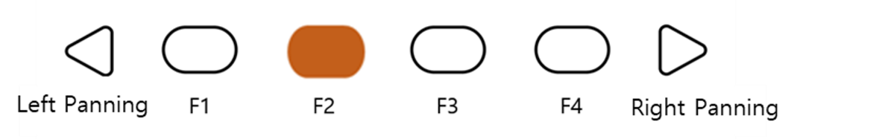
In the Create Canvas page, pressing the F2 button will select the 'Pen Tool' among the drawing tools.

- Erase All
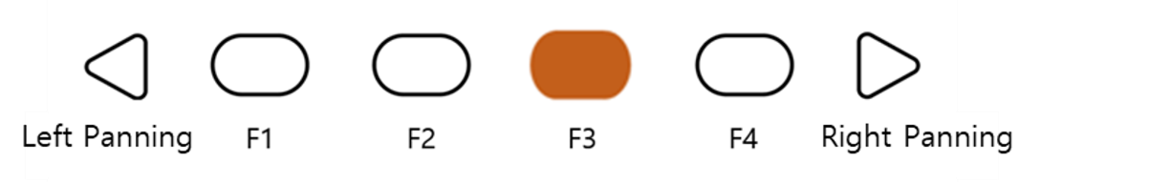
Users can press the F3 key to activate the undo function in the drawing tool.

- Add a New Page
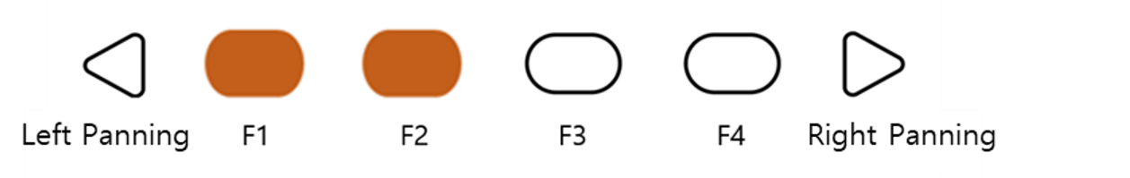
Users can press F1 and F2 together to add a new page to the canvas. Users can move to the next page by pressing the F1 and F4 buttons.

- Delete Current Page
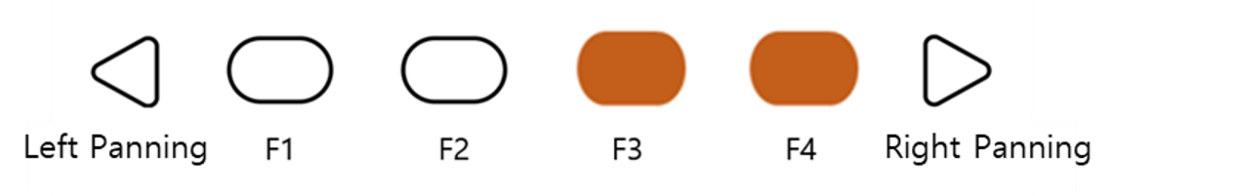
Users can delete their current canvas by pressing the F3 and F4 button together. After deleting the page, users can move pages with buttons F1 and F4.

- Changing Canvas Mode
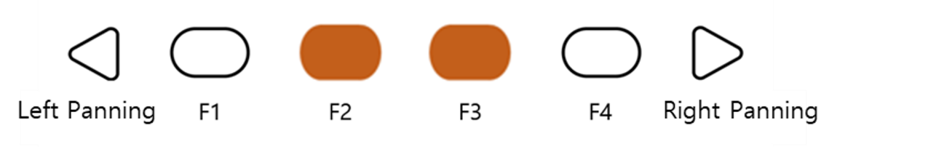
As a user-friendly application, Dot Canvas provides a mode that allows visually impaired users to draw and use the tools easily. Users can press F2 and F3 together to change the mode.

※ Types of Canvas Mode

- Canvas Navigating Mode
: Before drawing on the iPad, users can find the position of their finger.
If they touch the iPad screen in navigating mode, the Dot Pad will display the
Position of the finger with a crosshair cursor. When the finger stops at a certain
position, the cursor will start to blink.

- Draw Mode
: After deciding their position to start the drawing with the navigating mode, users can start drawing with draw mode by pressing F2 and F3 at the same time.

- Menu Navigation Mode
: In Menu Navigation Mode, users can pan around the drawing tool menu located on the top of the canvas. When the mode is at menu navigation mode, the canvas becomes deactivated, and the users will not be able to draw on the canvas even when they tap the canvas area.

Using Dot Canvas Web

Introducing Dot Canvas Web
Dot Canvas Web is a web version of tactile graphic creating tool optimized for the Dot Pad where users can create, save, and share digital tactile graphics. With user-friendly tools, anyone can effortlessly create, edit, and save their own tactile content, and use this content to their tailored needs, whether for education, creative projects, or other applications.
Users can upload image files onto Dot Canvas Web to convert it into tactile graphics automatically. With Dot’s braille translator, it is possible to print braille from texts on the Dot Pad in real time. Dot Canvas Web allows multiple units of Dot Pad to be connected and displayed at once.
※ Dot Canvas Web is available only with PC that supports Bluetooth.

Screen Layout of Dot Canvas Web
The screen layout of Dot Canvas Web is as follows.
- Dot Canvas
- Create or edit tactile graphics using various drawing/editing tools.
- Print the content that you have created onto the Dot Pad.
- Dot Cloud
- Upload and save the tactile graphic that you have created onto your Personal Drive or Public Drive.
- You can share your Personal Drive content to the Public Drive. In the Public Drive, you can access, edit shared content by others, and save it to your Personal Drive.
- Print the content uploaded from your Personal Drive and Public Drive onto the Dot Pad.
- Dot Support
- Update the firmware of your Dot Pad to the latest version.
- Submit an inquiry or leave feedback.

Starting Dot Canvas Web
- Go to apps-dotincorp.com.
- Create an account by signing up and log into Dot Canvas Web.
※ Dot Canvas (Web) and Dot Canvas (App) share the same account
※ Chrome is the recommended browser.
- If you have forgotten your username or your password, use the e-mail address code verification method to find your username or reset your password.

Connecting Dot Canvas Web to Dot Pad
To connect the Dot Pad to Dot Canvas Web, follow these steps:
- Open Dot Canvas and click the [Dot Pad] icon located at the top-right corner of the screen.
- Click [Search Device] to search for nearby Dot Pad devices.
- Select your desired Dot Pad from the list and click [Pair] at the bottom.
- If you wish to connect multiple devices, repeat the steps.

When the Dot Pad is successfully connected, the Dot Pad vibrates twice.

Troubleshooting Connection Issues
If the Dot Pad that you want to connect is not in the list of available devices, please check the following.
- Check the power status of the Dot Pad:
- If the Dot Pad is turned off, turn it on and click [Search].
- Check the Bluetooth status of the PC:
- If the Bluetooth of the device is turned off, turn Bluetooth on and click [Search].
- Check if the Dot Pad is connected to iOS VoiceOver. If paired with VoiceOver, follow the steps below and unpair the device:
- Apple [Settings] > [Accessibility] > [VoiceOver] > [Braille]
- Scroll all the way down and select the Dot Pad that is connected and go to [More Information]
- Click [Forget this Device] and unpair the Dot Pad.

Disconnecting the Dot Pad
Go into the Dot Pad Connect pop-up screen and select [Disconnect]. The Dot Pad will be disconnected with two long vibrations.

Using Dot Canvas Web Features

Create Canvas
Use various drawing/editing tools to create any shapes and images freely and insert multiline Braille text. Dot Canvas screen layout is as follows:

- Top Right
- Profile Button: Users can check the account’s profile, connect/disconnect the Dot Pad, and log in/out of the account.
- Language Button: Users can select the default language as Korean or English.
- File Management Menu:
- New: New canvas is created for the user to create new drawings.
- Open: Users can open the content from their Personal Drive or Public Drive.
- Add: Users can add tactile image files that are in a DTMs or DTMa format.
※ DTMs and DTMa are file formats that the Dot Pad supports.
- Export: Users can save the currently created canvas as a DTMs or DTMa file.
- Save: Users can save the current canvas onto the Dot Drive.
- Save As: Users can save the current canvas onto the Dot Drive with a different file name.
- File Name: The current file name of the canvas will be shown. If there is no file name, it will be shown as “Untitled.”
- Drawing/Editing Menu
- It is located on the left side of the Dot Canvas Web screen.
- It is used to create or edit tactile graphics on the canvas.
- Drawing/Editing Menu are as follows:

Table 2 Dot Canvas Web Drawing Tools
 | Undo/Redo  Undo or redo the latest work |  | Pen Size  Choose the thickness of the pen
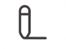 | Pen  Draw freely | 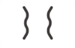 | Vertical Mirror Pen  Draw a symmetrical image
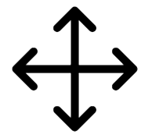 | Move  Recognize and move images on the current page as one object |  | Paint Bucket  • Fill in the selected area  • Used for closed shapes and lines
 | Erase  • Delete the area you want to modify  • The size of the eraser is proportional to that of the pen. |  | Clear  Delete everything from the current page
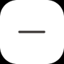 | Line  • Draw straight lines, diagonal lines, etc.  • Press [Shift] while drawing with this tool to create a straight line |  | Square/Rectangle  • Draw squares/rectangles  • Press [Shift] and drag to create a square
 | Circle  • Draw circles/ovals  • Press [Shift] and drag to create a perfect circle |  | Triangle  • Draw triangles, right triangles, etc.  • Press [Shift] and drag to create an acute triangle
 | Text Box  Create a text box within the graphic area and translate any text inside into braille. Create a text box by dragging with the mouse, enter the desired text, then press [ESC] followed by [Enter] to insert it. |  | Image  • Automatically converts tactile graphics by reading stored image files and setting the minimum and maximum value.  • Click [Insert] to convert the image into tactile graphics onto the canvas
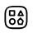 | Templates  A repository that organizes a variety of shapes in one location | 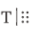 | Multi Braille  Allows users to create multi-line braille by typing or by importing PDF files and converting them into multi-line braille
 | Rectangle Selection  Use shortcut keys to copy, cut, and paste, or delete the selected area within the selection.  Copy selected area: [Ctrl + C]  Cut selected area: [Ctrl + X]  Paste selected area: [Ctrl + V]  Delete selected area: [Delete]  Deselect selected area: [ESC] |  | Lasso Selection  Use shortcut keys to copy, cut, and paste, and delete the selected area within lasso tool.  Copy selected area: [Ctrl + C]  Cut selected area: [Ctrl + X]  Paste selected area: [Ctrl + V]  Delete selected area: [Delete]  Deselect selected area: [ESC]
 | Tactile Letters  Converts typed text into tactile graphic representations of the letters

Table 3 Dot Canvas Drawing Tools Shortcuts
Keys | Edit Tool | Keys | Edit Tool
Top bar
Ctrl+O | Open | Ctrl+S | Save
Ctrl+Shift+S | Save As
Page Description
Alt+P | Print
Multi-Page
Ctrl+G | On/Off Grid
Editing Tool
P | Pen | V | Vertical Mirror Pen
Ctrl | Horizontal Axis  (while using vertical mirror pen) | Shift | Horizontal and vertical axis  (while using vertical mirror pen)
M | Move | B | Paint Bucket
E | Eraser | Ctrl+E | Eraser All
L | Line | R | Rectangle
C | Circle | T | Triangle
X | Text Box | I | Image
S | Rectangle Selection | H | Lasso Selection
Selection
Ctrl + X | Cut Selected Area | Ctrl + C | Copy Selected Area
Ctrl + V | Paste | DEL | Delete Selected Area

- Presentation Mode
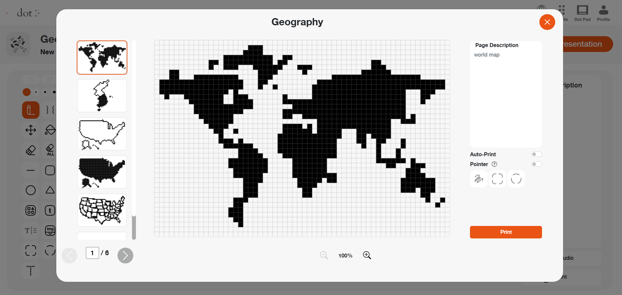
- Presentation Mode offers dynamic learning experience by utilizing Dot Pad and digital tactile graphics in classroom settings.
- Select the Presentation Mode button located in the upper right corner of the Dot Canvas Web screen.
- (1. Auto Print) When DotPad is connected to Dot Canvas Web, users can utilize the auto print feature.
- With the auto print feature enabled, every time users specify an area using the presentation mode pointer, the selected area will automatically be displayed on the DotPad.
- (2. Pointer) Highlight a specific area on the current canvas page using the three types of pointers, and the selected area will be displayed on DotPad.
- (3. Zoom In & Our) To zoom in on the screen, click the magnifying glass icon located at the bottom of the pop-up window. The display can be magnified up to 400% (4x).
Use the scroll bars on the right and bottom of the screen to navigate the enlarged area as needed.

- Multi-Page Management Bar
- This is located on the left side of the canvas. Users can select to show/ hide grid, arrange the order of the pages, delete pages, and add pages.
※ Grid: Users can choose to show the grid on the drawing area using the grid on/off button.
- Ctrl key + Up/Down Arrow keys: User can rearrange the order of the pages.
- Canvas
- The Canvas is a white drawing screen that takes up the biggest part on the screen.
- Users can create new content using the drawing/editing tool or open an existing content from the drive.
- Page Description
- It is located on the right side of the canvas.
- Users can add descriptions to the images they are creating.
- Descriptions are automatically converted into braille and are displayed correctly only if the input language matches the braille language selected in the Dot Canvas settings.
- Add Voice
- Users can insert an MP3 file into a specific page. When the file is opened in Dot Cloud, the audio information will play along with the corresponding page output.
- Print
- It is located below Page Description.
- Once the user clicks [Print], the image on the canvas and the accompanying description will be printed on the Dot Pad.

Dot Cloud
Users can save their created content onto the Dot Drive or share it with other people. Users can also print various tactile graphics onto the Dot Pad that are saved on the Public Drive.

Dot Drive is separated into a Personal Drive and the Public Drive. The Personal Drive is the default selected drive when the user first clicks on [Dot Drive]. The Dot Drive screen layout is as follows:

- Personal Drive ([User’s Name]’s Drive)
- Files saved or folders created on Dot Canvas will be saved here.
- Folders are displayed first before files.
- Users can open files, share, download, rename, copy, cut, paste, or delete by right clicking the file and then selecting the desired option.
- Click [+] to create a new file, new folder, or upload a file. Users can also right click on the empty space in the drive.
- Users can share the files in their Personal Drive to the Public Drive.
※ Right click on the file you want to share and click [Share]. If you edit a shared file, the shared file will be edited as well.
※ The shared file from the personal drive will show the creator’s icon on the thumbnail.
- Public Drive
- Shared folders and files are saved here.
- The shared files can be displayed onto the Dot Pad.
- Users can download the shared files onto the computer or open the file to edit them on Dot Canvas.
- Search
- Users can locate folders and files.
- If users type in the search box, files or folders with matching names will be listed.
- Back and Forth Buttons
- If you click the back button, the page will be redirected to the previous directory.
- If you click the forward button, the page will be redirected to the next directory.
- Gallery View Button
- The default mode of the Dot Drive is gallery view mode.
- The list of folders and files are displayed in the form of a gallery where icons are visible.
- List View Button
- The files will be displayed in list mode.

Updating Firmware in Dot Support Page
You can update the firmware of the Dot Pad from the Support page on Dot Canvas Web.
Here is how to update the Dot Pad firmware:
- Go to Dot Canvas Web at apps-dotincorp.com
- Select the Dot Support tab within Dot Canvas Web.
- Connect the Dot Pad to your PC via the USB C port located on the left side of your Dot Pad. After connecting, turn on the Dot Pad and press the Connect Device button on the Dot Support page.
※ Ensure the device remains powered on and the cable is securely connected throughout the update process.
- Connect the Dot Pad by selecting one of the wired port options that appears in the pop-up. If a connection failure notice is displayed, turn the Dot Pad off and on again and try again. After connecting, you can check the device information on the Dot Support page and update it to the latest firmware.
- Select the [Update] button at the bottom of the Dot Pad Firmware Version Information to proceed with the firmware update. The update takes about 3 to 5 minutes depending on the Internet speed.
※ If the firmware is in the latest version, an "Already the latest version of firmware" notice will be displayed.

User Guide: Using the Dot Pad 320 with NVDA

Introduction

Overview of Using NVDA with the Dot Pad 320
NVDA (NonVisual Desktop Access) is a free, open-source screen reader developed and distributed by NV Access for the Microsoft Windows operating system. Designed for individuals with visual impairments or low vision, NVDA provides voice and Braille output, allowing seamless navigation and management of Windows applications. Developed with contributions from NV Access and a global community, NVDA is a leading accessibility tool in the Windows environment.
Dot Inc. has developed and provides an NVDA Dot Pad 320 driver to ensure seamless integration with the NVDA screen reader and the Dot Pad 320, tactile graphic display. Install the Dot Pad 320 driver and experience digital information in a new and effective way with it. Utilize NVDA and the Dot Pad 320 to enhance information accessibility and increase work efficiency.

Feature Overview
NVDA is a screen reader designed to assist visually impaired users in navigating and interacting with the Windows operating system and various applications. The NVDA Dot Pad 320 driver enhances NVDA by connecting it with the Dot Pad 320, offering a multi-line display that provides an experience beyond traditional Braille displays. The following features are available once the NVDA Dot Pad 320 driver is installed:
- Automatically detects and connects to the Dot Pad 320 when NVDA is started or running.
- Allows users to switch the connection to the Dot Pad 320 when connected to a different Braille display.
- Converts NVDA's output into Braille data and displays it on the Dot Pad 320.
- Displays screen content read by NVDA simultaneously in the 300-cell multi-line area and the 20-cell area of the Dot Pad 320.
- Displays different content simultaneously on the 300-cell multi-line area and the 20- cell area while independently controlling each.
- Outputs Microsoft Excel and PowerPoint chart data on the Dot Pad 320.
- Refreshes the display on the Dot Pad.
- Uses the Dot Pad 320 button keys to control NVDA's basic navigation functions and scroll through multi-line Braille and chart data on the Dot Pad 320.

System Requirements
- Operating System: Windows 8.1 or higher
※ Windows 10 or higher recommended.
- NVDA Version: NVDA 2023.4 or higher
※ NVDA 2024.1 or higher recommended.

Starting Guide for Using NVDA with the Dot Pad 320

Installation and Setup
This section covers the installation and execution of NVDA and the NVDA Dot Pad 320 driver.

Installing NVDA
Before you can use NVDA with the Dot Pad 320, NVDA must be installed. NVDA can be downloaded from the 'Download' page on the NV Access website. For detailed information about downloading NVDA, initial setup, and running it, please refer to the 'NVDA User Manual.'

Installing the NVDA Dot Pad 320 Driver
To connect and use NVDA with the Dot Pad 320, the NVDA Dot Pad 320 driver must be installed. The following steps guide you through installing and running the NVDA Dot Pad 320 driver file:
- Click the link to ‘Download NVDA Dot Pad 320 driver’, or scan the QR code below to download the NVDA Dot Pad 320 driver installation file.
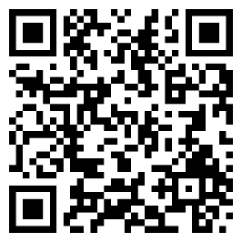
- Download the NVDA Dot Pad 320 driver installation file to the laptop or computer you will execute it on.
- Run the downloaded NVDA Dot Pad 320 driver installation file while NVDA version 2023.4 or higher is running.
- If a notification popup asks, "Would you like to install the NVDA add-on?", select Yes (Y) to install the add-on.
- If a notification popup asks, "Would you like to restart NVDA?", select Yes (Y) to restart NVDA and apply the changes from the add-on.
- Once NVDA restarts, the NVDA Dot Pad 320 driver installation is successfully completed.

Connecting the Dot Pad 320 to NVDA
The Dot Pad 320 can be connected to NVDA wirelessly using BLE (Bluetooth Low Energy).
※ Ensure the NVDA Dot Pad 320 driver is installed before attempting to connect the Dot Pad 320 to NVDA.
Users can automatically connect to any recognized Dot Pad 320 in the vicinity or manually specify and connect to a particular Dot Pad 320.

Automatic Connection
When NVDA is running, it detects any active Dot Pad 320 nearby and automatically attempts to connect with the device that has the strongest connection signal.
※ If another Braille display is already connected, the automatic connection feature of the Dot Pad 320 may not function.
- Go to NVDA menu > Settings > NVDA Settings > Braille.
- Set the Braille display to connect automatically.
- In the checkbox for displays to automatically search, select Dot Pad 320.
- Press the OK button, and the Dot Pad 320 with the strongest connection signal near the host device (PC) will be automatically selected and connected.
※ When the NVDA Dot Pad 320 driver is installed, Dot Pad 320 is typically pre-selected in the list of displays to automatically search.

Manual Connection
If NVDA is already connected to another Braille display or if automatic connection fails, users can manually select and connect to Dot Pad 320 through NVDA settings.
- Navigate to NVDA menu > Settings > NVDA Settings > Braille.
- Click the 'Change' button and select Dot Pad 320 from the list of Braille displays that appears.
- Press the Tab key to select the Bluetooth name of the Dot Pad 320 you have from the port list.
- Press the OK button, and a vibration will confirm the connection to the Dot Pad with the matching Bluetooth name, and Braille output will begin.
- Once the selection is complete, press the Apply button followed by the OK button to finalize the connection.

Learning Basic NVDA Shortcuts and Operations
Before using the Dot Pad 320 with NVDA, it is beneficial to familiarize yourself with NVDA's basic shortcuts and operations. This knowledge will allow you to effectively utilize the features of both NVDA and the Dot Pad 320. Refer to the NVDA User Guide to learn about the essential command keys and commonly used shortcuts.
- Running NVDA
- NVDA Basic Commands

Navigating NVDA with the Dot Pad 320
NVDA uses two types of cursors: the system focus and the navigator object. The Dot Pad 320 features two display areas—multi-line and single-line—and with the NVDA Dot Pad 320 driver, each cursor can be appropriately utilized within these distinct display areas. The single-line Braille display corresponds to the system focus, while the multi-line area is aligned with the navigator object. Users can effectively manage both cursors simultaneously, allowing for easy access to information and an efficient, novel experience in accessing information.

Navigating System Focus with the Dot Pad 320
The system focus in NVDA refers to the default cursor in Windows that can be moved using keyboard arrow keys or the Tab key. This focus allows for interaction with the spacebar or Enter key and encompasses all screen elements that can be focused using the Tab key. For example, users can navigate between controls by pressing the Tab key and Shift + Tab. And move to the menu bar with the Alt key, then use the arrow keys to navigate through the menus.
NVDA reads out changes when this system focus shifts. If the NVDA Dot Pad 320 driver is properly installed and running, the content of the system focus is simultaneously displayed in Braille on the Dot Pad 320's single-line display.
Some useful commands for navigating with the NVDA system focus include:
Table 1 Useful commands for navigating with the NVDA System focus
Name | Desktop Key | Laptop Key | Description
Report focus | NVDA+tab | NVDA+tab | Reports the current control which has focus. Pressing twice will spell the information. Pressing three times  will spell it using character description.
Window title | NVDA+t | NVDA+t | Reports the title of the currently active window.  Pressing twice will spell the information. Pressing three times will copy it to the clipboard
Read window | NVDA+b | NVDA+b | Reads the entire current window (useful for dialogs)
Read status bar | NVDA+end | NVDA+shift+end | Reports the Status Bar if NVDA finds one. Pressing twice will spell the information. Pressing three times  will copy it to the clipboard

Navigating the System Caret with the Dot Pad 320
Like other screen readers, NVDA uses the system caret within editable text areas or virtual cursors, including those in web browsers. The system caret is the method for navigating text within an editable text area or virtual cursor. Users can move character by character, word by word, or line by line using this navigation. Unless otherwise configured, when the NVDA system caret moves, the Braille cursor in both the single-line and multi-line areas of the Dot Pad synchronizes and moves accordingly.
Commands to move the system caret utilize standard Windows arrow key navigation. To navigate different text areas independently with the system caret and the NVDA review cursor, press NVDA + 6 to turn off "Follow the system caret." With this setting turned off, moving the system caret with arrow keys does not move the review cursor, so the Braille cursor in the Dot Pad's multi-line area does not move.
For more details, refer to section <12.1.12.2. Follow System Caret> in the official NVDA User Guide.

Navigating the Navigator Object with the Dot Pad 320
Typically, when using screen readers like NVDA, navigation is performed using the system focus and system caret. However, for navigating the screen in a hierarchical manner or in special cases such as with touch input displays, the NVDA navigator object is used. When navigating the screen using the navigator object, the content read by NVDA from this object is displayed in Braille on the Dot Pad 320 multi-line display. Additionally, the NVDA review cursor associated with the navigator object also appears on the Dot Pad 320 multi-line display.
For detailed information about the navigator object and review cursor, including shortcuts, please refer to the following sections in the NVDA User Guide:
- 5.4 Object Navigation
- 5.5 Reviewing Text
- 5.6 Review Mode
Understanding the navigator object and review cursor is crucial for utilizing the dual Braille display functionality covered in later sections, so it is essential to become familiar with these features.

Navigating NVDA Using the Dot Pad 320 Button Keys
Users can directly control NVDA and navigate the screen using the button keys on the Dot Pad. This includes many functions that are available on other braille displays, as well as unique capabilities of the Dot Pad 320, such as scrolling through multi-line Braille and reading chart data. The commands that can be utilized using the button keys on the Dot Pad 320 are as follows:
Table 2 Dot Pad 320 button keys usage
Name | Dot Pad Key | Description
Scroll to the previous line in  single-line braille | Left Pan (Triangular) | Scroll back through the braille text displayed in the 20-cell  braille area of the Dot Pad.
Scroll to the next line in  single-line braille | Right Pan (Triangular) | Scroll forward through the braille text displayed in the 20-  cell braille area of the Dot Pad.
Scroll back in multi-line braille | F1 Key | Scroll back in the multi-line braille area of the Dot Pad, where possible.  In the chart area, move to the previous chart data.
Scroll forward in multi-line braille | F4 Key | Scroll forward in the multi-line braille area of the Dot Pad.  In the chart area, move to the next chart data.
Move back | F2 Key | Move to the previous location in Windows Explorer.  This action is equivalent to pressing the Backspace key or Alt + Left Arrow key.
Activate the current navigator object | F3 Key | Execute the currently focused navigator object.  This is similar to pressing NVDA + Enter. f the system focus is synchronized with the navigator object, it is  equivalent to pressing the Enter key.
Move to the previous item | Left Pan + F1 Key | Move the system focus to the previous item from the current position.  This is similar to pressing the Up Arrow key on a PC or  Space + dot 1 on a standard Braille display.
Move to the Next item | Right Pan + F4 Key | Move the system focus to the next item from the current position.  This is equivalent to pressing the Down Arrow key on a PC  or Space + dot 4 on a standard braille display.
Move to the first item in the current window | F1 + F2 Key | Move the system focus to the first item in the current window.  In applications like text editors that use the system caret, this  moves the cursor to the very first character.
Move to the last item in the current window | F3 + F4 Key | Move the system focus to the last item in the current window.  n applications like text editors that use the system caret, this  moves the cursor to the very last character.

Using NVDA with the Dual Braille Display of the Dot Pad 320
When using the Dot Pad 320 with NVDA, it is possible to read two different screen contents simultaneously in Braille. For example, a user can display a webpage in the multi-line area while reading the content of a text editor in the single-line Braille display, allowing them to work efficiently. Alternatively, it is possible to read different sections of a document at the same time in Braille. This capability utilizes the fact that NVDA's system focus and navigator object can focus on separate screen areas. The detailed steps are as follows:
- Focus on the content you want to reference in the multi-line Braille area.
- Press NVDA + 7 to turn off "Follow Navigator Object System Focus."
It is also recommended to press NVDA + 6 to turn off "Follow System Caret" at the same time.
- The navigator object remains fixed in the specified area and no longer follows the system focus. Only the content of the navigator object is displayed in Braille in the Dot Pad 320 multi-line area.
- Navigate primarily in the working area, such as a text editor, using the system focus.
- To navigate using the focus of the navigator object in the multi-line area, use the navigator object keyboard commands and review cursor keyboard commands.
Commands for the navigator object and review cursor that are useful when using the dual braille display with NVDA are as follows:

NVDA Navigator Object Commands
Table 3 NVDA Navigator object commands
Name | Desktop Key | Laptop Key | Description
Report current object | NVDA+  numpad5 | NVDA+shift+o | Reports the current navigator object. Pressing twice spells the information, and pressing 3 times copies this  object's name and value to the clipboard.
Move to containing object | NVDA+  numpad8 | NVDA+shift+ upArrow | Moves to the object containing the current navigator  object
Move to previous object | NVDA+  numpad4 | NVDA+shift+  leftArrow | Moves to the object before the current navigator object
Move to next object | NVDA+  numpad6 | NVDA+shift+  rightArrow | Moves to the object after the current navigator object
Move to first contained object | NVDA+  numpad2 | NVDA+shift+  downArrow | Moves to the first object contained by the current navigator object.
Move to focus object | NVDA+  numpadMinus | NVDA+  backspace | Moves to the object that currently has the system focus,  and places the review cursor at the position of the System caret, if it is showing.
Move System focus or caret to current review position | NVDA+shift+  numpadMinus | NVDA+shift+  backspace | pressed once Moves the System focus to the current navigator object, pressed twice moves the system caret to the position of the review cursor
Activate current navigator object | NVDA+  numpadEnter | NVDA+enter | Activates the current navigator object (similar to clicking with the mouse or pressing space when it has the system focus)
Report review cursor location | NVDA+Shift+  numpadDelete | NVDA+Shift+  delete | Reports information about the location of the text or object at the review cursor. For example, this might include the percentage through the document, the distance from the edge of the page or the exact screen position. Pressing twice may provide further detail.

NVDA Review Cursor Commands
Table 4 NVDA Review cursor commands
Name | Desktop Key | Laptop Key | Description
Move to top line in review | shift+numpad7 | NVDA+control+  Home | Moves the review cursor to the top line of the text
Move to previous line in review | numpad7 | NVDA+upArrow | Moves the review cursor to the previous line of text
Report current line in review | numpad8 | NVDA+shift+. | Announces the current line of text where the review cursor is positioned. Pressing twice spells the line. Pressing three  times spells the line using character descriptions.
Move to next  line in review | numpad9 | NVDA+  downArrow | Move the review cursor to the next line of text
Move to bottom  line in review | shift+numpad9 | NVDA+control+  End | Moves the review cursor to the bottom line of text
Move to previous word in review | numpad4 | NVDA+control+ leftArrow | Moves the review cursor to the previous word in the text.
Report current word in review | numpad5 | NVDA+control+. | Announces the current word in the text where the review  cursor is positioned. Pressing twice spells the word. Pressing three times spells the word using character descriptions.
Move to next  word in review | numpad6 | NVDA+control+  rightArrow | Move the review cursor to the next word in the text
Move to start of  line in review | shift+numpad1 | NVDA+home | Moves the review cursor to the start of the current line in the  text
Move to previous character in  review | numpad1 | NVDA+leftArrow | Moves the review cursor to the previous character on the current line in the text
Report current character in review | numpad2 | NVDA+. | Announces the current character on the line of text where the review cursor is positioned. Pressing twice reports a description or example of that character. Pressing three times reports the numeric value of the character in decimal and  hexadecimal.
Move to next character in  review | numpad3 | NVDA+  rightArrow | Move the review cursor to the next character on the current line of text
Move to end of  line in review | shift+numpad3 | NVDA+end | Moves the review cursor to the end of the current line of text
Say all with  review | numpadPlus | NVDA+shift+a | Reads from the current position of the review cursor, moving  it as it goes
Select then Copy from review  Cursor | NVDA+f9 | NVDA+f9 | Starts the select then copy process from the current position of the review cursor. The actual action is not performed until  you tell NVDA where the end of the text range is
Select then Copy to review cursor | NVDA+f10 | NVDA+f10 | On the first press, text is selected from the position previously set as start marker up to and including the review cursor's current position. If the system caret can reach the text, it will be moved to the selected text. After pressing this key stroke a second time, the text will be copied to the  Windows clipboard

Converting Microsoft Excel Charts on the Dot Pad 320
When connected with NVDA, if you are using a spreadsheet document or PowerPoint that includes charts, you can read the content of the charts as text while verifying it as a bar graph. The bar graph is transformed and displayed in the multi-line area of the Dot Pad 320. Regardless of the chart type in the Microsoft document, it is converted into a bar graph when displayed on the Dot Pad 320. The detailed steps are as follows:
- Open a Microsoft Excel spreadsheet or PowerPoint document that contains charts.
- Press CTRL + Alt + 5 to navigate to the chart area.
- Use the arrow keys to move the focus to the chart title.
- The chart data appears as a bar graph on the Dot Pad 320 multi-line display.
- If the chart data is too extensive to be displayed at once, you can scroll through the chart data in the same way you would scroll through multi-line text using the button keys on the Dot Pad 320.

Guidelines for Configuring Dot Pad 320 in NVDA

Adjusting Settings for the Dot Pad 320 in NVDA

Braille Tethering (Default Automatic)
Braille tethering is the setting that determines which cursor's content will be displayed in Braille when NVDA outputs content on screen. By default, it is set to automatic tethering. When set to automatic, the contents of both the navigator object/review cursor and the system focus are output in Braille whenever their contents change. Users can choose to set the Braille output to follow either the system focus or the review cursor's content.
When using the Dot Pad 320, it is recommended to set the Braille tethering to system focus. This configuration naturally separates the system focus to the single-line Braille display and the navigator object and review cursor contents to the multi-line display, preventing confusion. The shortcut key to switch Braille tethering is NVDA + CTRL + T.

Setting Up the Dot Pad 320 Button Keys
Users can customize the button keys on the Dot Pad to perform different NVDA commands. The configuration process is similar to setting up standard keyboard commands. The detailed steps are as follows:
- Go to NVDA menu > Preferences > Input Gestures.
- Find the desired function in the feature category.
- Press the Tab key to select the "Add" button.
- Press the button key on the Dot Pad that you want to associate with this function. For example, pressing the F1 key in this mode will replace its existing function with scrolling back through the multi-line Braille.
- A dialog box will open asking whether to apply the setting across all keyboard layouts, only in the desktop layout, or just in the laptop keyboard layout.
- Use the arrow keys to focus on the desired keyboard layout and press Enter to select it.
- The keyboard command is now registered.

User Guide: Using the Dot Pad 320 with Jaws

Introduction

Introduction to Jaws
This manual provides instructions for connecting and using your Dot Pad with JAWS. It assumes you already have JAWS installed and working and are familiar with its documentation, where you can find comprehensive information on all the available Braille features.

System Requirements
To use the Dot Pad with JAWS, you will need:
Windows
- Version 10 or higher
Jaws
- Version 2025 or highert

Overview of the Connection Process

Connecting your Dot Pad to JAWS
Dot Connecting your Dot Pad to JAWS is a simple two-step process:
1. Connect the Dot Pad to your PC. You can use either a USB cable or a Bluetooth connection.
2. Configure JAWS to use the Dot Pad. This involves telling JAWS which device you are using and which type of connection you want to use.

Connecting with a USB Cable

To connect the Dot Pad using a USB cable
The easiest way to connect your Dot Pad to your PC is with a USB cable. You can use the cable supplied with the Dot Pad if your PC has a USB A port. You can also use a USB C to USB C cable if your PC has a USB C port.
1. Plug one end of the cable into the left-hand USB port on the Dot Pad. This is the data port and is labelled with a 'd' on top of the device near the port.
2. Plug the other end of the cable into a USB port on your PC.

Configuring JAWS for a USB Connection
Once the Dot Pad is connected with a USB cable, follow these steps to configure it with JAWS:
- Press INSERT+J to open the JAWS window.
- Press ALT+O to open the Options menu and select Braille to open the Braille Basic Settings dialogue box.
- Press TAB to move to the Add Braille Display button and press ENTER.
- In the list of Braille displays, choose Dot Pad, press the SPACEBAR to select it, and then choose Next.
- In the Select the output port dialogue box, choose Next.
- Ensure that the Dot Pad is selected as the primary display.
- Select Finish. You will be instructed to restart JAWS for the changes to take effect. Select OK to close this message and then again to close the Braille Basic Settings dialogue box.
- Quit and restart JAWS. Your Dot Pad is now communicating with JAWS over USB

Connecting via Bluetooth
Bluetooth connectivity is managed entirely within the JAWS Braille settings. The correct way to connect via Bluetooth is as follows:
- Press INSERT+J to open the JAWS window.
- Press ALT+O to open the Options menu and select Braille to open the Braille Basic Settings dialogue box.
- Press TAB to move to the Add Braille Display button and press ENTER.
- In the list of Braille displays, choose Dot Pad, press the SPACEBAR to select it, and then choose Next.
- In the Select the output port dialogue box, choose Next.
- Ensure that the Dot Pad is selected as the primary display.
- Select Finish. You will be instructed to restart JAWS for the changes to take effect. Select OK to close this message and then again to close the Braille Basic Settings dialogue box.
- Turn on the Dot Pad.
- Quit and restart JAWS.
- When JAWS restarts, a Bluetooth Scanner dialogue box will appear. Select your Dot Pad from the list and choose Connect.
The Bluertooth Scanner dialogue box will close, and the Dot Pad will be communicating with JAWS over Bluetooth.
Once JAWS is configured, it will automatically find and connect to your Dot Pad each time you restart it. For this to work, you must turn your Dot Pad on before you start JAWS.

An Overview of Using JAWS and Braille
Now that your Dot Pad is connected, you can test it by navigating Windows, the web, and apps on your PC. If you've used JAWS before, you'll feel right at home. If you are new to JAWS and Braille, please refer to the section "JAWS and refreshable Braille" in the JAWS help system for more details.

The Dot Pad Displays
The Dot Pad has two displays: a large, multi-line display and a single-line display. Unlike other screen readers, JAWS uses the large display for most of the Braille content. The single-line, 20-cell display is used for status cells.

On the 20-cell display:
The screen layout of Dot Canvas Web is as follows.
- The first three cells
- The first three cells show your horizontal (x-axis) pixel location (with an on-screen cursor), line number (with the Virtual Cursor), and/or Speech Output index number (in Speech Output mode).
- The fourth cell
- The fourth cell indicates the active cursor: p (PC Cursor), v (Virtual Cursor), j (JAWS Cursor), i (Invisible Cursor), or b (Braille Cursor).
- The fifth cell
- The fifth cell indicates the active Braille mode: l (Line), s (Structured), x (Speech Output), or i (Attribute).
If you are focused on a control in Structured Mode, the type of control is displayed by default in the status cells. For example, chk for a check box or btn for a button will appear when positioned on these control types. When multiple types need to be shown, the symbols will be combined into a single symbol that fits in the status area. For example, a graphic within a link would show ilnk, and a graphic that is part of a level 1 heading would show ih1.
Following this, you will see two numbers separated by a comma. The first number is the horizontal line on the Dot Pad where the cursor is located. The number after the comma is the character number on that line. This helps you quickly find the cursor anywhere on the display.

Navigating with the Buttons on the Dot Pad
The six buttons on the Dot Pad provide a convenient way to navigate and read directly from the device without needing to use your computer's keyboard. From left to right, they have the following functions:
- Pan Left: Displays the previous page of Braille.
- F1: Pans the split Braille region left.
- F2: Presses the Escape key.
- F3: Presses the Enter key.
- F4: Pans the split Braille region right.
- Pan Right: Displays the next page of Braille
You can also use the following key combinations:
- Pan Left + F1: Presses the Up Arrow key.
- Pan Left + F2: Presses the Left Arrow key.
- F1 + F2: Presses the Home key.
- F1 + F3: Presses Shift + Tab.
- F2 + F4: Presses the Tab key.
- F3 + F4: Presses the End key.
- F3 + Pan Right: Presses the Right Arrow key.
- F4 + Pan Right: Presses the Down Arrow key.
- F1 + F4: Invokes the Set Braille View dialogue box
If you forget what these keys do, you can turn on keyboard help by pressing JAWS Key + 1. The Dot Pad will then display the key(s) you pressed along with their function. You can turn keyboard help off again by pressing Escape or F2 on the Dot Pad.
All these keys can be remapped to any JAWS function using the JAWS keyboard manager. To learn how, refer to the topic "Using the Keyboard Manager" in the "Customizing JAWS for Windows" section of the JAWS help system.

Using Contracted Braille
When you set up JAWS for the first time, Computer Braille input is selected by default. To use contracted Braille, do the following:
- Press INSERT+F2 and select Settings Center.
- To apply changes to all applications, press CTRL+SHIFT+D to load the JAWS default settings. To apply changes to a specific application, select it from the Applications combo box.
- In the Search edit box, type "Translation" without the quotes.
- Press DOWN ARROW to move to Translation in the filtered search results in the tree view and press ENTER to move focus to the Translation group. Press RIGHT ARROW to expand the group.
- Press SPACEBAR to cycle through the different settings in the Output combo box to configure the mode for reading Braille.
The first option is always Computer Braille. The other available options depend on the currently selected language. For example, with English (United States) selected, the available output modes are U.S. English Grade 1, U.S. English Grade 2, Unified English Braille Grade 1, and Unified English Braille Grade 2.

Multi-line Braille Support

Wrapped mode
JAWS provides multi-line Braille support right out of the box. As you navigate web pages and documents, JAWS will display as much Braille as will fit on the Dot Pad. This is the default operation of JAWS and is known as Wrapped mode.

Cropped mode
If you are viewing a table or a spreadsheet, JAWS will automatically switch to show you as much of the current column as possible. As you navigate the table, vertical alignment is retained, making it easier to read and understand the information. This feature is known as Cropped mode, and JAWS will automatically switch to it when you are in a table or spreadsheet.

Set Braille mode
Yu can use the Set Braille View dialogue box to manually switch between these modes if you wish. You can activate this dialogue box by pressing F1+F4 on the Dot Pad. See the JAWS documentation for more details.

Using Split Braille
Split Braille allows you to view content from different locations on the same Braille display. When a Split Braille view is active, your display is split into two regions separated by a horizontal line.

Activating Split Braille
To enable a Split Braille view, press ALT+INSERT+V (ALT+CAPS LOCK+V in Laptop layout) to open the Select Braille View dialogue box. Alternatively, you can press F1+F4 on the Dot Pad.
When the dialogue box opens, you will be in a list of available views. Select the one you want to use and then select OK. The active view remains in effect for the current JAWS session. Restarting JAWS will return you to your default settings.
When a split view is active, your current location is displayed in region one (the top), and the content of the active view is displayed in region two (the bottom). If you want to change this, open the Select Braille View dialogue box again and select the Swap split button.
For most views, you can independently navigate the split region. To navigate text in the split view, use the F1 and F4 keys on the Dot Pad to pan left or right.
The default is No Split, where the entire multi-line display is used to present the Braille in the current application.
There are several Split Braille views, which you can read about in the JAWS documentation. For example, selecting Buffered Text captures the text at your current location and displays it in region two. Once the buffer is created, you can navigate to another location, or even a different document or application, while your buffered text remains available.
For more information on Split Braille, refer to the topic "Split Braille" in the "Using JAWS with Refreshable Braille" section of the JAWS help system.

Accessing Math Content with JAWS and Dot Pad
JAWS helps students read and study math problems in web pages and Microsoft Word documents using both speech and braille. It describes math expressions in clear, natural language, similar to how a teacher would explain them in a classroom. This lets students who use JAWS read math just like their sighted classmates

Reading Math on the Web
JAWS supports reading MathML content in Microsoft Edge, Google Chrome, and Mozilla Firefox. MathML is a web language that allows browsers to display math and science equations just as they would appear on paper.

When JAWS finds MathML on a webpage, it first describes the expression and then says, "math content." If you're using your Dot Pad with Contracted Braille enabled, your Dot Pad will show "Math" followed by the expression in Braille math code. If the expression is too long, you can use your Dot Pad's panning buttons to read the rest. If JAWS is set to Computer Braille, Dot Pad will show a message explaining that you need to enable Contracted Braille to view the math.

You can press Enter or F3 on your Dot Pad while focused on the math to open the Math Viewer, which lets you explore the expression in more detail with both speech and braille. You can exit the Math Viewer by pressing Escape or F2 on your Dot Pad.

Reading Math in Microsoft Word
When JAWS finds a math equation or formula in a Word document, it reads the problem aloud and says, "Math Content." You can then press the layered keystroke Insert + Spacebar, followed by the Equals key, to open the JAWS Math Viewer and study the equation in more detail. You can exit the Math Viewer by pressing Escape or F2 on your Dot Pad.

For a complete explanation of how to work with math and JAWS, including further details on navigating the Math Viewer, please refer to the Accessing Math content section of the JAWS help system.

User Guide: Using the Dot Pad 320 with VoiceOver

Introduction of VoiceOver & Dot Pad 320
VoiceOver is an advanced screen reader integrated into the Apple OS, designed to assist visually impaired users by providing auditory and tactile feedback.
When paired with Dot Pad 320, VoiceOver delivers tactile feedback for both text and graphics, creating a comprehensive and intuitive accessibility solution.
This synergy empowers visually impaired users to interact with their devices more effectively and productively.
The Dot Pad 320 enhances this experience by offering real-time braille output, similar to other braille displays, but with the added advantage of displaying multiple lines of braille simultaneously. This feature enables users to read large amounts of screen content more efficiently. The multi-line braille preview mode allows users to quickly and effectively understand the screen layout, revolutionizing productivity for screen reader users.

Furthermore, the Dot Pad can instantly display on-screen images as tactile graphics.
Users can zoom in and out or invert these images for detailed reading and scroll horizontally or vertically to explore large images thoroughly. Additionally, some applications allow users to perceive graphs tactilely on the Dot Pad, enhancing the overall accessibility experience.

Feature Overview
When connected to Apple VoiceOver, the Dot Pad offers the following features:

Note:
Features specified with an OS name in parentheses are exclusive to that OS. Features without an OS name are available across all Apple operating systems.

- Single-Line Braille Output:
The VoiceOver content is displayed in real-time as braille on the single-line braille
display of the Dot Pad 320.
- Multi-Line Braille Output (iOS & iPadOS):
Displays screen content in multi-line braille, allowing the use of preview mode and
other features with the multi-line braille display of the Dot Pad 320.

- Real-Time Tactile Image Display:
When the VoiceOver cursor focuses on a specific object on the screen, the corresponding image is displayed on the Dot Pad.

- Tactile Image Display Using VoiceOver Recognition:
Activating VoiceOver Recognition provides a description of the focused object or surrounding screen images in both audio and braille text, and simultaneously
displays the images tactilely on the Dot Pad.

- Graph Display:
Some applications, such as stock apps, can display graphs tactilely on the Dot Pad alongside with audio graphs (Sonification).

- VoiceOver Control and Shortcut Key Modification Using Dot Pad Buttons:
Interact with VoiceOver using the buttons on the Dot Pad, which can also be customized to perform specific VoiceOver commands.

System Requirements
The Dot Pad is compatible with VoiceOver on the following Apple operating systems:

- iOS 15.2 and later
- iPadOS 15.2 and later
- macOS 13.3 and later
- VisionOS 1.0 and later

Using the Dot Pad 320 with iOS & iPad OS

Feature Overview
In iOS and iPadOS, you can read screen content through VoiceOver on the Dot Pad as you would with any other braille display. Starting from iOS & iPadOS 18.0, users can utilize the multi-line braille output feature as well as read images and graphs tactilely.

System Requirements
Minimum Requirements: iPhone and iPad capable of running iOS or iPadOS 15.2 or later.
For Multi-Line Braille Output: iPhone and iPad capable of running iOS or iPadOS 18 or later.

Connecting the Dot Pad 320 to VoiceOver
Here are the steps to connect the Dot Pad to your iPhone or iPad:

- Turn on VoiceOver.
- Go to [Settings] > [Accessibility] > [VoiceOver] > [Braille]
- Check the Bluetooth device name of your Dot Pad and find the matching device in the list of devices displayed at the bottom of the screen connect it.
- When the Dot Pad vibrates and you hear the specific beep indicating that a braille device has been connected in VoiceOver, the connection is successful. And the LED light on the Dot Pad will turn blue.
Note:
To disconnect the connected Dot Pad from VoiceOver, press and hold the connected device or use the Actions menu in the VoiceOver rotor to select More, then tap Forget This Device. The Dot Pad will be disconnected.

Reading Content with Single-Line Braille Display
When VoiceOver and the Dot Pad 320 are successfully connected, the available functions that display the content on the Dot Pad 320 will depend on the iOS or iPadOS version you are using.

- iOS or iPadOS versions before 18.0:
The VoiceOver content will be displayed in real-time on the single-line braille display of the Dot Pad.

- iOS or iPadOS version 18.0 and above:
The content will be displayed on both the multi-line and single-line braille displays of the Dot Pad 320, allowing for more extensive content to be read simultaneously.

In single-line braille display, users can scroll through the content by lines:
- Left panning key (left triangular button): scroll to the previous line.
- Right panning key (right triangular button): scroll to the next line.

Reading Content with Multi-Line Braille Display
When VoiceOver and the Dot Pad are connected, users can simultaneously read screen content in multi-line braille. Multi-line braille offers the advantage of quickly and accurately reading large amounts of screen content. Additionally, the preview mode in multi-line braille output allows users to understand the screen layout more efficiently compared to traditional screen readers.

VoiceOver’s multi-line braille output feature provides four different modes to display screen content. These options can be adjusted in the VoiceOver Rotor under “Braille Text Mode.” The four options are as follows:

- Braille Text Mode > Reading Mode:
This is the default option for multi-line braille output. It displays text in the multi-line braille display if text is present and displays images if they are present.

- Braille Text Mode > Reading Mode (No Images):
This option ignores images and displays only text in the multi-line braille area.

- Braille Text Mode > Preview Mode:
This mode provides a brief list of items on the screen starting from the current position.

- Braille Text Mode > Images:
This option outputs only images and graphs in the multi-line braille area, excluding text.

By using these modes, users can customize their digital experience to best suit their needs, enhancing productivity and accessibility.

Basic Multi-Line Braille Output Mode (Braille Text mode > Reading Mode)
Reading Mode is the default option for displaying either braille text or graphics flexibly on the multi-line braille display, depending on the context. When the user focuses on an image or a graph, it is tactilely represented on the multi-line braille display and when the user focuses on text, up to eight lines of braille can be displayed.

When braille text is displayed, it appears starting from the topmost line, with the currently focused item at the top. Additionally, to indicate that it is the first item, a cell with all dots from 1 to 8 filled is displayed before the screen content.

To scroll through the multi-line braille display, use the F1 and F4 keys on the Dot Pad.
The single-line braille display is synchronized with the multi-line display.

Image Skipping Mode (Braille Text Mode - Reading Mode (No Images))
When the Reading Mode (No Images) option is selected in the Braille Text Mode Rotor, VoiceOver will not print graphical information even if the cursor is positioned on images or graphs. Instead, the multi-line braille display will show alternative text of the images, the name of the image control, or the name of the graph. This allows users to focus solely on text content while still recognizing the presence of images and graphs through alternative descriptions.

Quick Screen Navigation Mode (preview mode)
Preview Mode arranges the screen items sequentially on the multi-line braille display, starting from the current focus position. The Dot Pad can display up to eight screen items simultaneously, with each item’s text limited to 20 braille characters. If an item’s length exceeds 20 characters, the text after the 20th character will be omitted.

To read the summarized screen items in detail, read the single-line braille display. For example, to read the currently focused item on the first line in detail, press the right Panning key to explore the full content of the focused screen item.

Image Viewing Mode (Images)
When the Images option is selected, the Dot Pad operates similarly to how it does on iOS or iPadOS versions lower than 18.0. In this mode, the multi-line braille display will not show braille text. Instead, it will exclusively display images and graphs. For more detailed information on viewing screen images on the Dot Pad, please refer to section <2.6. Viewing Screen Images on the Dot Pad>.

Displaying Screen Images on the Dot Pad 320

Basic Image Output Setup
When VoiceOver focuses on an object containing image information, It is displayed on the Dot Pad 320 tactilely.

Steps:
- Ensure that the Dot Pad 320 is connected to your device and navigate to the Home Screen.
- Use VoiceOver to move the focus to any application icon on the Home Screen.
- The 300-cell graphic display on the Dot Pad will display the shape of the application icon. And the VoiceOver content will be displayed on the 20-cell of the Dot Pad 320 in braille.
By following these steps, users can easily perceive and interact with graphical information on their devices using the Dot Pad 320 with VoiceOver.

Zooming In/Out on images
VoiceOver allows you to zoom in or out on images displayed tactilely on the Dot Pad 320. This feature helps you read the details of an image more precisely. To use this feature, add the “Braille Zoom” option to your Rotor settings. Follow these steps to zoom images:

Steps:
- Place the VoiceOver cursor on the image you want to zoom in or out.
- Rotate two fingers on the screen (clockwise or anticlockwise) to select “Braille Zoom” from the Rotor.
- Swipe one finger down to zoom in on the image. Swipe one finger up to zoom out on the image.
- The zoom level ranges from 0% to 100%.
- The Dot Pad 320 will refresh immediately to be updated with the zoom changes.

By following these steps, users can easily adjust the image size on the Dot Pad to enhance your tactile reading experience.

Scrolling Through Images
When images are zoomed in, they might be larger than the display area of the Dot Pad 320. In such cases, users can use the image scrolling function to navigate through the enlarged image. Both horizontal and vertical scrolling are supported. To enable this feature, add “Braille Vertical Pan” and “Braille Horizontal Pan” to your Rotor settings. Follow these steps to scroll images:

Steps:
- Place the VoiceOver cursor on any image object (e.g., application icon or image).
- Horizontal Scrolling:
- Set the Rotor to “Braille Horizontal Pan”.
- Swipe one finger down to scroll the tactile graphic to the left.
- Swipe one finger up to scroll the tactile graphic to the right.
- Vertical Scrolling:
- Set the Rotor to “Braille Vertical Pan”.
- Swipe one finger down to scroll the tactile graphic upwards.
- Swipe one finger up to scroll the tactile graphic downwards.

By following these steps, users can navigate through the entire image even when it is larger than the Dot Pad 320’s display area, ensuring you can access all parts of the zoomed-in image effectively

Inverting Images
This feature allows users to convert the outlines of tactile images from raised to inverted, aiding in better understanding the image. Here’s how to use the image inversion feature:

- Place the VoiceOver cursor on any image object (e.g., application icon or image).
- Ensure the image is displayed on the Dot Pad 320’s graphic area.
- Set the Rotor to the “Invert braille” option.
- Swipe down with one finger to execute the inversion. The image on the Dot Pad 320 will switch from raised to inverted.
- To revert the image back to its standard mode, set the Rotor to the “Invert braille” option again.
- Swipe up with one finger to deactivate the inversion, returning the image to its original raised state.

Reading Images on the Dot Pad 320 with VoiceOver Recognition
Even if VoiceOver doesn’t initially recognize an object as an image, you can leverage the AI capabilities in iOS and iPadOS 14 and above to gather image information.
This analyzed image data is then conveyed via audio description and displayed on the Dot Pad 320 as tactile graphics and braille.

To use VoiceOver Recognition, users need to configure a custom gesture for the manual VoiceOver Recognition command. Please follow these steps:

- Go to [Settings] > [Accessibility] > [VoiceOver] > [VoiceOver Recognition].
- Ensure the Image Descriptions toggle is switched on. If not, double tap the toggle to turn it on.
- The necessary data for image descriptions will download.
- Once the download is complete, use a back gesture or the back button to return to the VoiceOver settings.
- Go to [Commands] > [Touch Gestures] and select Desired touch gesture in VoiceOver gestures list. Find and add Image Descriptions.
- With this custom gesture set up, users can now use it to trigger AI-based image descriptions anywhere on the screen.

After setup, VoiceOver will then provide descriptions of the focused object or the surrounding screen area, displaying the information as tactile graphics on the Dot Pad.

Reading Graphs
Users can view stock graphs on the Dot Pad 320 using a stock application by following these steps:

- Launch the stock application on your device.
- Choose the stock you would like to analyze.
- Move the VoiceOver focus to the area displaying stock graph.
- The stock graph will appear on the Dot Pad 320, allowing you to read the graph tactilely.

Dot Pad Shortcut List in iOS & iPadOS
Here are the default VoiceOver commands that can be used with the keys on the Dot Pad:

Table 1Default VoiceOver Commands with the Dot Pad 320 buttons.
Name | Key | Description
Single-Line Braille Display Left Pan | Left Pan Key | Scrolls the single-line braille display to the previous line.
Multi-Line Braille Display Left Pan | F1 Key | Scrolls the multi-line braille display to the previous unit.
Move to Home | F2 Key | Moves to the home screen.
Activate Selected Item | F3 Key | Activates the currently focused item (equivalent to a double tap with one finger).
Multi-Line Braille Display Right Pan | F4 Key | Scrolls the multi-line braille display to the next unit.
Single-Line Braille Display Right Pan | Right Pan Key | Scrolls the single-line braille display to the next line
Move to the Previous Item | Left Pan + F1 Key | Moves to the previous item from the current position (equivalent to a left swipe with one finger).
Move to the Next Item | Right Pan + F4 Key | Moves to the next item from the current position (equivalent to a right swipe with one finger).
Move to the First Item | F1 + F2 Keys | Moves to the first element on the screen (equivalent to a four-finger tap at the top of the screen).
Move to the Last Item | F3 + F4 Keys | Moves to the last element on the screen (equivalent to a four-finger tap at the bottom of the screen).

These commands enable users to effectively navigate and interact with their devices using the Dot Pad in conjunction with VoiceOver.

Modifying Dot Pad Shortcuts
Users can customize the panning keys and function keys on the Dot Pad 320 to match their own preferences. For example, you can change the F1 key from navigating to the previous item to toggling the screen curtain. Here’s how to do it:

- With the Dot Pad connected, go to [Settings] > [Accessibility] > [VoiceOver] > [Braille].
- Find and focus on “DPA320A xxxx (the unique Bluetooth name of your device)”.
- Adjust the Rotor option to Actions. The default Rotor option is set to Actions.
- Swipe up/down with one finger to find [More Info], then double tap to select it.
- Locate and execute the [Braille Commands] button to display the list of command categories.
- Select the desired category from [Braille], [Device], [Interaction], [Keyboard], [Navigation], [Rotor], and [VoiceOver].
- In this document, select [Navigation] as an example.
Go to [Navigation] > [Move to Next Paragraph] > [Assign New Braille Key].
- When the key input pop-up appears, press the Dot Pad function key you want to assign to the Move to Next Paragraph function.
- In this document, modify the F2 key as an example.
- When user presses the F2 button, a warning message will appear stating that the F2 key is already in use.
- To override and reassign the key, execute the [Assign New Braille Key] button.
- Now, the F2 key will function to move to the previous paragraph.
- To retain the original key assignment, use the VoiceOver back gesture to exit the warning pop-up.

Using the Dot Pad with macOS
This section provides a comprehensive guide on connecting and using the Dot Pad with macOS VoiceOver. Before proceeding, please familiarize yourself with the following key terms:

- VO Key:
This term refers to the modifier key combination used for executing VoiceOver commands. The VO Key can be the Control Key + Option Key or the Caps Lock Key.

- VoiceOver Utility:
This is a sub-menu within the Accessibility settings where you can manage all VoiceOver settings.

- Groups and Hierarchy:
macOS VoiceOver organizes on-screen objects into a hierarchical structure. For example, in the Mail application, to locate buttons like New Mail and Delete, you must navigate within the toolbar hierarchy. Similarly, tables are presented as upper-level structures, and to read the contents of individual cells, you must delve into the table’s lower hierarchy. This hierarchical organization follows the tree structure defined by SwiftUI or UIKit.

Understanding these terms will help you navigate and use the features of the Dot Pad more effectively with macOS VoiceOver.

Feature Overview
In macOS, Users can read screen content through VoiceOver on the Dot Pad just like any other braille display. Additionally, users can read images and graphs tactilely. This is particularly helpful for tasks such as viewing images on web pages or understanding slide layouts in Apple Keynote or Microsoft PowerPoint. It also aids in identifying broken and non-broken tables by interacting with screen readers and tables.

System Requirements

- macOS 13.3 and later
- Preferably a Mac computer with Apple Silicon
- A Mac computer that supports Bluetooth devices

Connecting the Dot Pad to VoiceOver
Here are the Steps to Connect Dot Pad to macOS VoiceOver

- Launch the VoiceOver Utility by pressing VO Key + F8.
- Navigate to the Braille category.
- Select the Displays tab.
- Turn on your Dot Pad.
- Click the Add button to open a window for scanning nearby braille displays.
- If your Dot Pad has entered Bluetooth pairing mode correctly, its Bluetooth name will appear in the list of devices.
- Focus the cursor on it using the Tab key, trackpad, or by navigating into the sub-group and select the connect button.
- If the connection is successful, you will receive vibration feedback on the Dot Pad.
- Click the Select button to register the Dot Pad as a braille display.
- Upon successful connection, VoiceOver will emit a beep sound indicating the braille display is connected. The screen content read by VoiceOver will start displaying in braille on the single-line area of the Dot Pad.

Reading Screens with Single-Line Braille Display
When VoiceOver and the Dot Pad are successfully connected, the single-line braille display will show the screen content read by VoiceOver in real-time. You can scroll through the content line by line. Use the left triangle button on the Dot Pad, known as the left pan key, to scroll to the previous line. Similarly, use the right triangle button, known as the right pan key, to scroll to the next line

Displaying Screen Images on the Dot Pad

Basic Image Output Settings
When VoiceOver focuses on an object containing image information, that image is displayed on the Dot Pad.

- Navigate to the Dock while the Dot Pad is connected.
- Focus on any application in the Dock menu.
- Alternatively, open a web page and focus on any image within the page.

The graphic area of the Dot Pad will display the application icon or image, while the text area will display the content read by VoiceOver in braille.

Zooming In/Out on Images
On macOS, unlike iOS or iPadOS, you cannot use the Rotor to zoom in or out on images. Instead, you must create a shortcut key for zooming. For instructions on creating these shortcuts, refer to <3.7. Creating VoiceOver Shortcuts for Dot Pad>.

- Position the VoiceOver cursor on the image you want to zoom in on.
- Press the shortcut key assigned to the “Zoom in” function to enlarge the image.
- To reduce the size of the zoomed-in image, press the shortcut key assigned to the “Zoom out” function.
- The zoom range is from 0% to 100%.
- As the image is zoomed in or out, it will be immediately refreshed on the Dot Pad.

Scrolling Through Images
The concept of scrolling images on the Dot Pad in macOS is similar to iOS or iPadOS. However, it requires assigning specific shortcut keys for scrolling, as it cannot be adjusted using the Rotor. You will need shortcut keys for all four directions: Move Down, Move Left, Move Right, and Move Up. When you scroll the image in the desired direction, the image displayed on the Dot Pad will move accordingly.

- Assign shortcuts for Move Down, Move Left, Move Right, and Move Up.
- Use these shortcuts to scroll the image in the respective directions on the Dot Pad.

Inverting Images
The inverting images feature in macOS operates similarly to its counterparts in iOS and iPadOS. However, macOS requires you to create specific shortcut keys rather than using the Rotor. By selecting the toggle invert function, you can switch between inverted mode and the standard image display mode.

Reading Images on the Dot Pad with Voiceover Recognition
To use VoiceOver Recognition in macOS, the default shortcut key is VO + Shift + “L”. Follow these steps to use it:

- Focus on the screen element for which you want to hear an image description or view the tactile image.
- Press VO + Shift + “L”.
- An image description will be provided, and the image will be displayed on the Dot Pad.

These steps ensure users the full capabilities of VoiceOver and Dot Pad for both standard and advanced image handling, enhancing the overall accessibility experience.

Dot Pad Shortcut List in macOS
Here are the shortcuts users can use to control VoiceOver on the Dot Pad while using macOS:

Name | Key | Description
Single-Line Braille Display Left Pan | Left Pan Key | Scrolls the single-line braille display to the previous line.
Move to the Previous Item | F1 Key | Moves the VoiceOver cursor to the previous item from the currently focused item (Equivalent to QuickNav On mode left arrow key or VO + left arrow key).
Dock Menu | F2 Key | Moves to the Dock menu (Equivalent to VO + d key).
Activate Selected Item | F3 Key | Activates the item currently under the VoiceOver cursor (Equivalent to QuickNav On mode down arrow key + up arrow key or VO + Space key).
Move to the Next Item | F4 Key | Moves the VoiceOver cursor to the next item from the currently focused item (Equivalent to QuickNav On mode right arrow key or VO + right arrow key).
Single-Line Braille Display Right Pan | Right Pan Key | Scrolls the single-line braille display to the next line.

Creating VoiceOver Shortcuts for the Dot Pad 320
To utilize functions like image enlargement, scrolling, and inversion with Dot Pad on macOS, you need to create custom shortcuts. Follow these steps:

- Press VO + F8 to open the VoiceOver Utility.
- Select Commands from the category list.
- In the Command Set group, choose the User Custom radio button.
- Click the Edit button.
- Click Add to create a new empty command set.
- Navigate to the Command Assignments table.
- Click the added none popup button to expand the modifier key group options. Choose from Option Key, Quick Nav keys, NumPad, or Trackpad.
- Specify values from a to z or 0 to 9 within the chosen group.
- Open the Command Actions popup menu, find and expand the 2D Braille category.
- Select the desired Dot Pad function from the list.
- Click the Done button to complete the assignment.

Now, pressing the specified shortcut will enable detailed image reading on the Dot Pad.

Modifying Dot Pad Shortcuts in VoiceOver
Users can modify the default VoiceOver commands assigned to Dot Pad keys. Here’s how:

- Press VO + F8 to open the VoiceOver Utility.
- Select the Braille category.
- Click the Displays tab.
- Select Dot Pad from the braille display list and click the Assign Commands button.
- In the Braille Commands table, click the Action button next to the Dot Pad key you want to modify (e.g., F2 key).
- Find and select the desired VoiceOver function from the relevant category.
- Click the Done button to complete the key modification.
To assign new functions to empty keys without changing the default Dot Pad key assignments, Please follow these steps:

- Press VO + F8 to open the VoiceOver Utility.
- Select the Braille category.
- Follow the procedures outlined above to create and assign new command actions to empty key values.

These instructions will help you customize the Dot Pad for a more tailored and efficient use with macOS VoiceOver.

